NITROGEN FIXATION IN FIELD-GROWN LEGUMES MEASURED BY
THE ¹⁵N ISOTOPE DILUTION AND THE DIFFERENCE METHODS

A THESIS SUBMITTED TO THE GRADUATE DIVISION OF THE
UNIVERSITY OF HAWAII IN PARTIAL FULFILLMENT
OF THE REQUIREMENTS FOR THE DEGREE OF

MASTER OF SCIENCE
IN AGRONOMY AND SOIL SCIENCE
AUGUST 1986

by

Wilson Emaanzi Kagabo

Thesis Committee:
James A. Silva, Chairman
Paul W. Singleton
Mitiku Habte

We certify that we have read this thesis and that in our opinion it is satisfactory in scope and quality as a thesis for the degree of Master of Science in Agronomy and Soil Science.
ACKNOWLEDGEMENTS

The author wishes to express his sincere appreciation to the Liberian and United States Governments for their support through the scholarship awarded to him.
Special thanks are given to the Director of Central Agricultural Research Institute Suakoko, Liberia for allowing him to pursue the graduate study.
Appreciation is also extended to the NifTal Project of the University of Hawaii for their assistance and the use of their facilities.
Most of all my appreciation and thanks to my parents for their encouragement and motivation.
TABLE OF CONTENTS
Page
ACKNOWLEDGEMENTS ................................................. 3
LIST OF TABLES ................................................... 7
LIST OF FIGURES .................................................. 11
I. INTRODUCTION .................................................. 16
II. REVIEW OF LITERATURE ......................................... 19
2.1. Nitrogen Fixation ..................................... 19
2.2. Inoculation ........................................... 19
2.3. Methods of Measuring N₂ fixation ...................... 21
2.4. Nitrogen Balance or Difference Method ................. 21
2.5. The ¹⁵N Isotope Dilution method ....................... . 22
2.6. Nitrogen Balance vs the ¹⁵N Isotope Dilution ........... 23
2.7. Residual Nitrogen ..................................... 26
III. FIELD ESTIMATES OF NITROGEN FIXATION ........................ 28
3.1. Materials and Methods ................................. 28
3.1.1. Location and Soils ............................ 28
3.1.2. Land Use ...................................... 28
3.1.3. Experimental Design ........................... 28
3.1.4. Treatments .................................... 29
3.1.5. Inoculation and Planting ...................... 29
3.1.6. Fertilizer and ¹⁵N Application ................. 30
3.1.7. Determination of Indigenous Rhizobia in Kuiaha
Soil ........................................... 30
TABLE OF CONTENTS (continued)
3.1.8. Sampling and Nitrogen Determination ............ 31
3.1.9. Statistical Analysis ........................... 32
3.2. Results and Discussion ................................. 33
3.2.1. Inoculation Response ........................... 33
3.2.2. Early Yield and Nodulation Indices ............. 33
3.2.3. Evaluation of Reference Crops .................. 35
3.2.3.1. Total N Uptake ......................... 35
3.2.3.2. Atom % ¹⁵N Excess ....................... 37
3.2.3.3. ¹⁵N Dilution Method ..................... 42
3.2.3.4. Harvest Date by Reference Crop
Interaction by the ¹⁵N Method ........... 42
3.2.3.5. Difference Method ...................... 45
3.2.3.6. Harvest Date by Reference Crop
Interaction by the Difference Method ... 51
3.2.4. Nitrogen Fixation Estimates by the ¹⁵N Method ... 60
3.2.5. N₂ Fixation Estimates by the Difference Method.. 62
3.2.6. Comparison of the Methods ...................... 64
IV. RESIDUAL NITROGEN ............................................. 76
4.1. Materials and Methods .................................. 76
4.1.1. Land Preparation ............................... 76
4.1.2. Experimental Design ............................ 76
4.1.3. Treatment Design ............................... 76
4.1.4. Planting and Management ........................ 76
4.1.5. Harvest and Data Collection .................... 78
4.2. Results and Discussion ................................. 78
TABLE OF CONTENTS (continued)
4.2.1. N Yield ........................................ 78
V. CONCLUSIONS .................................................... 81
APPENDICES ........................................................ 83
I ........................................................... 83
II .......................................................... 84
III ......................................................... 88
IV .......................................................... 89
V ........................................................... 92
VI .......................................................... 101
BIBLIOGRAPHY ...................................................... 102
LIST OF TABLES
Table Page
1 Total N yield and rate of N accumulation (g day⁻¹)
in field-grown legumes 35 days after emergence ........ 36

2 Effect of reference crop on N₂-fixation estimates
(kg ha⁻¹) in field-grown legumes as determined by
the ¹⁵N isotope dilution method ......................... 43

3 Effect of reference crop on N₂-fixation estimates
(kg ha⁻¹) in field-grown legumes as determined by
the ¹⁵N isotope dilution method ......................... 44

4 Effect of reference crop on nitrogen fixation estimates
(kg ha⁻¹) in field-grown legumes as determined by the
difference method ...................................... 52

5 Effect of reference crop on nitrgen fixation estimates
(kg ha⁻¹) as determined by the difference method ........ 53

6 Effect of harvest dates on nitrogen fixation estimates
(kg ha⁻¹) in field-grown legumes determined using the
¹⁵N isotope dilution method ............................. 61

7 Effect of harvest dates on nitrogen fixation estimates
(kg ha⁻¹) in field-grown legumes as determined using
the difference method .................................. 63

LIST OF TABLES (continued)
8 Summary of regression analysis for comparison of N
fixation estimates by the difference and ¹⁵N isotope
dilution methods in field-grown legumes................. 74

9 Effect of residual nitrogen of field-grown legumes on
total N yield of a subsequent crop of sweet corn ....... 80

10 Number of viable cells of peat-based rhizobia
inoculants as determined by the plate count method ..... 83

11 Determination of indigenous rhizobia in Kuiaha soil
by MPN method using cowpea plant infection count ....... 84

12 Determination of indigenous rhizobia in Kuiaha soil
by MPN method using peanut plant infection count ....... 85

13 Determination of indigenous rhizobia in Kuiaha soil
by MPN method using soybean plant infection count ...... 86

14 Determination of indigenous rhizobia in Kuiaha soil
by MPN method using bushbean plant infection count ..... 87

15 Early dry matter yield, percent N, nodule count and
dry weight in field-grown legume species ............... 88

16 Nitrogen distribution estimates (kg ha⁻¹) in
field-grown legumes as determined by the ¹⁵N isotope
dilution method ........................................ 89
LIST OF TABLES (continued)
17 Nitrogen distribution estimates (kg ha⁻¹) in
field-grown legumes as determined by the ¹⁵N isotope
dilution method ....................................... 90

18 Nitrogen distribution estimates (kg ha⁻¹) in
field-grown legumes as determined by the ¹⁵N isotope
dilution method ....................................... 91

19 Dry matter yield of field-grown legumes and sweet corn
(kg ha⁻¹) 30 days after emergence ...................... 92

20 Percent shoot N of field-grown legumes and sweet corn
30 days after emergence. .............................. 93

21 Dry matter yield of field-grown legumes and sweet corn
(kg ha⁻¹) 60 days after emergence ...................... 94

22 Percent plant N of field-grown legumes and sweet corn
60 days after emergence. .............................. 95

23 Dry matter yield of field-grown legumes and sweet corn
(kg ha⁻¹) 80 days after emergence ...................... 96

24 Percent plant N in field-grown legumes and sweet corn
(kg ha⁻¹) 80 days after emergence ...................... 97

LIST OF TABLES (continued)
25 The ¹⁵N enrichment in field-grown legumes and
sweet corn 30 days after emergence .................... 98

26 The ¹⁵N enrichment in field-grown legumes and
sweet corn 60 days after emergence .................... 99

27 The ¹⁵N enrichment in field-grown legumes and
sweet corn 80 days after emergence .................... 100
LIST OF FIGURES
Figure Page
1 Effect of inoculation on N yield in field-grown
legume species at 30, 60, and 80 days after
emergence ............................................. 34

2 Total N yield of three reference crops at 30, 60, and
80 days after emergence ............................... 38

3 ¹⁵N enrichment in non-fixing soybean, bushbean, and
corn reference crops .................................. 39

4 ¹⁵N enrichment in field-grown N fixing legumes ......... 40

5 Total N yield (kg ha^{-l}) in field-grown legumes and
corn .................................................. 41

6 Effect of harvest date and reference crop on N
fixation estimates for inoculated cowpea calculated
using the ¹⁵N method with soybean and corn as reference
crops ................................................. 46

7 Effect of harvest date and reference crop on N
fixation estimates for uninoculated cowpea calculated
using the ¹⁵N with soybean and corn as reference
crops ................................................. 47

LIST OF FIGURES (continued)
8 Effect of harvest date and reference crop on N
fixation estimates for inoculated peanut calculated
using the ¹⁵N method with soybean and corn as reference
crops .................................................. 48

9 Effect of harvest date and reference crop on N
fixation estimates for uninoculated peanut calculated
using the ¹⁵N method with soybean and corn as reference
crops .................................................. 49

10 Effect of harvest date and reference crop on N
fixation estimates for inoculated soybean calculated
using the ¹⁵N method with soybean and corn as reference
crops .................................................. 50

11 Effect of harvest date and reference crop on N
fixation estimates for inoculated cowpea calculated
using the difference method with soybean and corn as
reference crops ........................................ 55

12 Effect of harvest date and reference crop on N
fixation estimates for uninoculated cowpea calculated
using the difference method with soybean and corn as
reference crops ........................................ 56

LIST OF FIGURES (continued)
13 Effect of harvest date and reference crop on N
fixation estimates for inoculated peanut calculated
using the difference method with soybean and corn as
reference crops ........................................ 57

14 Effect of harvest date and reference crop on N
fixation estimates for uninoculated peanut calculated
using the difference method with soybean and corn as
reference crops ........................................ 58

15 Effect of harvest date and reference crop on N
fixation estimates for inoculated soybean calculated
using the difference method with soybean and corn as
reference crops ........................................ 59

16 Relationship between the difference and ¹⁵N methods
for the amount of N fixed at 30 days after emergence
using uninoculated soybean as the reference crop.
Each bullet represents one of the 21 plus other hidden
individual observations ............................... 65

17 Relationship between the difference and ¹⁵N methods
for the amount of N fixed at 30 days after emergence
using uninoculated bushbean as the reference crop.
Each circle represents one of the 48 individual
observations ........................................... 66

LIST OF FIGURES (continued)
18 Relationship between the difference and ¹⁵N methods for
the amount of N fixed at 30 days after emergence using
corn as reference crop. Each block represents one of
the 48 individual observations ........................ 67

19 Relationship between the difference and ¹⁵N methods for
the amount of N fixed at 60 days after emergence using
uninoculated soybean as the reference crop. Each bullet
represents one of the 48 individual observations ...... 68

20 Relationship between the difference and ¹⁵N methods for
the amount of N fixed at 60 days after emergence using
bushbean as the reference crop. Each circle represents
one of the 48 individual observations ................. 69

21 Relationship between the difference and ¹⁵N methods for
the amount of N fixed at 60 days after emergence using
corn as the reference crop. Each block represents one
of the 48 individual observations ...................... 70

22 Relationship between the difference and ¹⁵N methods for
the amount of N fixed at 80 days after emergence using
uninoculated soybean as the reference crop. Each bullet
represents one of the 40 individual observations ....... 72

LIST OF FIGURES (continued)
23 Relationship between the difference and ¹⁵N methods for
the amount of N fixed at 80 days after emergence using
corn as the reference crop. Each block represents one
of the 40 individual observations ...................... 73

24 Treatment design layout ................................ 77

25 Layout for the ¹⁵N microplot ............................ 101
I. INTRODUCTION
Legume crops are important because of their ability to fix atmospheric nitrogen through symbiosis with rhizobia. In the tropics where the majority of the population obtains its living from the land, legumes are likely to increase in importance. Legumes form a major component of tropical agrosystems (Norman, 1982; Rachie, 1977; and Okigbo, 1977) and can provide cash income to the farming community. Food legumes provide large quantities of good quality dietary protein to the population and legumes also help to maintain a reasonable level of soil fertility.
Cropping systems involving monoculture of non-leguminous plants cause a decline of yields and depletion of soil nitrogen. This decrease in productivity in the past, especially in tropical Africa, has been alleviated by shifting cultivation or more recently by the use of inorganic fertilizers. As the population increases, the resulting pressure on the land has made shifting cultivation untenable. Recent increases in prices of synthetic fertilizer have also made it difficult for small farmers to use inorganic nitrogen for crop production. Consequently, biological nitrogen fixation becomes the only alternative source of nitrogen for crop production.
If biological nitrogen fixation by legumes is to become a sustained reliable source of nitrogen for crop production, certain questions have to be answered. How much nitrogen do various legumes fix? How much residual nitrogen do legumes supply to the cropping systems? However, these questions and many others can not be answered without a reliable method to estimate biological nitrogen fixation. Reliable estimates of biological nitrogen fixation will allow selection of superior N₂-fixing legume species. Gibson et al. (1977) for instance, indicated that biological nitrogen fixation (BNF) can be improved by: (1) growing better cultivars adapted to specific environments, (2) inoculation with the most effective and competitive strains of Rhizobia, and (3) the application of management practices designed to minimize the impact of nutritional and environmental limitations.
Literature suggests that there are several methods that can be used to estimate field N²-fixation. The ¹⁵N isotope dilution and the difference methods are among the most widely used for estimating field nitrogen fixation by legumes. There are advantages and disadvantages associated with each method. The advantage of the difference method is that, it is inexpensive, simple and does not require special techniques and equipment which are needed for the ¹⁵N isotope dilution method.
The ¹⁵N isotope dilution method which was first described by MacAuliffe et al. (1958) has been used recently by many workers (Fiedler et al., 1972; Fried et al., 1977; Vose et al., 1981; Rennie et al., 1982; Rennie and Kemp, 1983 a,b; Rennie et al., 1984; Rennie and Dubetz, 1984) to estimate field N₂-fixation by various legumes. The advantage of the ¹⁵N isotope dilution method is that it makes it possible to separate N taken up by the plant from fertilizer and soil from that fixed in the plant. Many workers have described the ¹⁵N isotope dilution method as the most reliable measure of N₂-fixation (Gibson et al., 1977; Amarger et al., 1979; Larue and Patterson, 1982). The accuracy of either method depends on the type of reference crop used. The best reference crop should be closely related to the test plant. This can be either an uninoculated plant, a non-nodulating isoline, or a cereal such as corn. An assumption in all cases is that the test plant and control both have the same root systems exploring the same volume of soil. In soils where native rhizobia do not nodulate the test plant, the ideal reference crop is the uninoculated test plant. Where the native rhizobia nodulate the test plant however, the appropriate reference crop is not readily apparent. It is also not clear whether there is agreement between the ¹⁵N isotope dilution and the difference methods.
Although there are many problems associated with the measurement of the gross amount of N fixed by a legume over the whole period of its growth, the residual nitrogen contribution to the soil-plant system can be determined through a series of measurements including the portion of N derived from mineralization, the residual N that was taken up by the plant, and the portion that remains in the soil.
The objectives of this study were to: (1) determine the relationship between the ¹⁵N isotope dilution and the difference methods, (2) investigate the field inoculation response of field-grown legumes, (3) quantify the amount of nitrogen fixed by each species using the two methods, (4) determine the best reference crop for N fixation estimates in cowpea and peanut, and (5) determine the residual nitrogen contribution to a subsequent corn crop.
II. REVIEW OF LITERATURE
2.1. Nitrogen Fixation
Although peanut is a leading legume crop in most tropical countries, little information regarding its nodulation is available. It is known that about 30% of the cowpea group of rhizobia nodulate peanut effectively and the remainder are ineffective (Dobereiner 1977). The amount of N₂ fixed has not been determined, but effective nodulation of naturally-occurring peanut strains has been studied. In West Africa effective nodulation was observed to occur only during the second year of cultivation. Sen et al. (1981) observed that values for acetylene reduction activity and nitrogen accumulation in the plant top per unit nodule mass of peanut were several times higher than values for cowpea and siratro. They also reported a 30% increase in shoot weight, a 125% increase in nitrogenase activity, a 112% increase in nodule number and a 19% inoculant recovery in inoculated peanut following amendment of the soil to raise pH from 4.6 to 6.5. However, increasing pH to 7.1 caused these values to decrease. Liming to such a high pH reduces the availability of most micronutrients some of which are essential for nitrogen fixation. The author further observed significant differences among cultivars in nitrogen fixation and accumulation in stems and leaves. Graham et al. (1981) recommended the use of strains which function well at a specific pH. The findings by these workers emphasize the importance of soil reaction on N fixation.
2.2. Inoculation
Hadad et al. (1982), observed little benefit from inoculating peanut. Nambiar et al. (1983), working with peanut, observed that in the field, where inoculated strains have to compete with the native rhizobium population, the number of rhizobia required to produce maximum nodulation is likely to be larger than that needed under glasshouse conditions. In another study, Nambiar et al. (1982) observed that inoculation of peanut seeds with liquid culture applied to the soil below the seed proved superior to either granular or conventional slurry inoculation. Liquid inoculant enhanced germination of seedlings and resulted in significantly enhanced grain yields.
Grown mainly in Africa and South America, cowpeas nodulate apparently effectively in most areas without inoculation. Kang et al., (1977), while working with cowpea in western Nigeria, did not find any need for inoculation as indigenous strains were capable of good nodulation. Mughogho et al. (1982) reported that yield responses to both fertilizer nitrogen and rhizobium inoculation in cowpea were small, indicating that factors other than nitrogen supply were limiting yield. These findings indicate the need to study inoculation response in cowpea under tropical soils.
Soybeans, while reported or known to be sub-tropical plants, have been extended into tropical areas by recent breeding programs. Dobereiner et al. (1977) reported that inoculation of soybean is essential in new areas and in acid soils. They further stated that selection of the appropriate rhizobium strains is essential for new cultivars and consideration must be given to the soil and climate into which the crop is being introduced. Nelson et al. (1980) however, reported total plant nitrogen of 75 kg ha^{-l} in a non-nodulating isoline and more than 300 kg ha⁻¹ in a nodulating isoline. Philip et al. (1975) reported that successful introduction of soybean in the tropics will depend on successful inoculation, since it is widely known that yields are closely correlated with amount of nitrogen accumulated throughout its life cycle. Vest (1971) observed that non-nodulating soybean genotypes benefited from being grown with nodulating types. Benefits were increase in seed weight and seed number, probably through utilization of nitrogen fixed by the nodulating line. Lathwell et al. (1952) reported that high levels of nitrogen must be available during the bloom period to obtain maximum pod set in soybean. Bhangos et al. (1976) observed that since soybean can utilize both soil nitrogen and symbiotically fixed nitrogen, evaluation of nitrogen fixation by soybean, under field conditions, is difficult since the amount of symbiotically fixed nitrogen decreases with an increase in available soil nitrogen or applied nitrogen.
2.3. Methods of measuring N₂ fixation
Acetylene reduction assay is one of the several methods used to measure N₂ fixation by crops. However, this method is one-time estimate of fixation and can not be used to measure N fixation integrated over time. Indices of nodulation, number of nodules, fresh and dry weight of nodules, leghemoglobin concentration in nodules or per plant may be related to nitrogen fixation within a single cultivar. However, there is no evidence that these nodule-related characters can be used to measure the amount of N₂-fixation by crops. Other methods include the concentration of the ureides allantoic acid and allantoin in the shoots of N fixing legumes. These have been reported to correlate well with the amount of nitrogen fixed by legumes. However, more information is still needed as regards the ease and accuracy of this method. Other methods include the difference or the nitrogen balance and the isotopic methods.
2.4. Nitrogen Balance or the Difference Method
The simplest method used to estimate the amount of nitrogen fixed is by the total nitrogen accumulation in the crop. The total N content of the non-fixing crop (derived solely from soil N) is subtracted from the total N content of the N-fixing legume. Three versions of the difference method are commonly used. (1) comparison of a legume with a nonlegume, (2) comparison of a legume with a nonnodulating legume, and (3) comparison of inoculated and uninoculated legumes. An assumption in the use of total N to determine the amount of nitrogen fixed is that the test plant and the control plant both have similar patterns of soil N uptake. However, information to date shows that at low levels of soil nitrate, nodulating plants exhibit higher nitrate reductase activity than non-nodulating plants (Harper, 1974). The author concluded that N fixation could not be estimated by the comparison of nodulating and non-nodulating isolines at low nitrate level as the latter were stunted, because nitrate utilization was impaired.
Larue et al. (1981) indicated that a closer approximation to N fixed using nitrogen balance may be achieved by analyzing changes in soil N as well as that removed in the crop. An adjusted measure of N₂ fixation by the nitrogen accumulation technique is obtained when the contribution of soil N to the total N of legumes is estimated. These findings indicate that nitrogen fixation can not be estimated by the difference method using non-nodulating isoline as reference crop at low nitrate level.
2.5. The ¹⁵N Isotope Dilution Method
The ¹⁵N isotope dilution method, like the difference method, requires a non-fixing control to estimate the relative contribution of soil and fertilizer N. In this method the fixing crop and a non-fixing control are grown in soil to which ¹⁵N has been added as a small amount of labeled nitrate or ammonium. Many workers reported that the ¹⁵N isotope dilution method is more accurate than the difference method. Vose et al. (1981) reported that the advantage of using ¹⁵N in quantifying N₂-fixation is that one can separate the effects of fertilizer and soil N on nitrogen fixation. It is also possible to separates the effects of agronomic practices which may affect yield in ways other than nitrogen fixation. Fried et al. (1977) indicated that to determine the amount of nitrogen fixed by a legume using the ¹⁵N isotope dilution method, it is necessary to apply ¹⁵N labeled fertilizer to both the N₂-fixing and the non-fixing plants. Then the atom % ¹⁵N excess in both plants are determined. The amount of N₂-fixed can then be calculated from the following equation:
Amarger et al. (1979) indicated that when nitrogen fixation activity of nodulated plants varies, either because of the variety, level of fertilizer N or the time samples were taken, a proportional variation of isotopic N composition is observed. These variations are incorporated in the estimates of the proportion of nitrogen fixed, which is justified. They further reported that inoculation of soybean led to a decrease in the soil-derived N uptake and a lower ¹⁵N content in the nodulated than non-nodulated soybean. The N₂-fixation estimates given by ¹⁵N were correlated with C₂H₂ reduction activity but not with the differences in N yield. The results of these workers indicate that it is justified to use the variations in the isotopic N composition caused by the variety or species, level of fertilizer N, or the time when samples are taken, to estimate the nitrogen fixed.
Fiedler et al. (1972), reported that routine analysis of ¹⁵N in agricultural samples is a problem facing many agricultural research stations because mass spectrometers are often not available and the investigators must depend on the services of other departments for the work. Proksch (1969) reported that the Dumas method is acceptable for outline analysis of ¹⁵N in plant material. When the enrichment is low, i.e., below 5% atom excess, the systematic errors introduced by nonrandom pairing of N atoms is negligible. The slightly higher ¹⁵N values found when Dumas values are compared with Kjeldahl values are probably due to the more complete conversion of NO₃ in the sample with the Dumeis procedure. Rennie et al. (1982), used the ¹⁵N isotope dilution method with two Canadian soybean cultivars and observed that N yield of inoculated cultivars was not affected by increasing rates of N application. The highest fertilizer use efficiency was 51% and 44% in uninoculated and inoculated cultivars, respectively. Both cultivars had similar percent N derived from the atmosphere (% Ndfa) and amount of N fixed ha⁻¹.
2.6. Nitrogen Balance vs the ¹⁵N Isotope Dilution Methods
Talbott et al. (1982), reported that estimates from the difference method and ¹⁵N method for the amount of total N₂-fixed were highly correlated. The % N derived from fixation varied between the two methods, and was attributed to spatial variation of available soil nitrogen. Vasilas et al. (1984) evaluated the N₂-fixation measurement techniques and found that estimates by the difference method exceeded those by isotope dilution by an average of 5%, which was very small compared to the total variation. They also observed that the difference method provided representative N₂-fixation values where soil N conditions permit proper development of non-nodulating control plants, but do not depress N₂-fixation. The difference method and isotope dilution technique gave similar estimates at the 100 kg N rate with low soil N and at the 10 kg N rate with higher soil N. These findings indicate that over a wide range of soil N regimes, the difference method gives as accurate a measure of N₂-fixation as the more expensive and complicated isotope methods. Rennie (1984) obtained different results when he evaluated two techniques commonly used to estimate N₂-fixation over the growing season in field-grown legumes. The total nitrogen balance method (difference method) generally gave a lower estimate of N₂-fixation and was consistently less precise (higher experimental error). Good agreement between the two methods was found in 70% of the experiments in which the amount of N₂-fixed was estimated, but in only 60% of the experiments in which the percentage N₂-fixed was estimated. He also indicated that nitrogen balance method was most reliable in experiments where soil N was low, so that non-fixing plants showed signs of N deficiency by anthesis. He concluded that the nitrogen balance (difference method) cannot be used with confidence to estimate N₂-fixation in field-grown legumes.
Rennnie et al. (1984) used ¹⁵N to determine N₂-fixation in two cultivars of field beans receiving two rates of fertilizer N. At 10 kg N ha⁻¹, the amount fixed ranged between 114 and 124 kg ha⁻¹. The cultivar that fixed more nitrogen was observed to have a longer vegetative phase. Thus, indicating that cultivars of field beans with longer vegetative phases tend to fix more nitrogen. The authors concluded that when field beans are properly inoculated, they obtain more than 60% of their N from N₂-fixation and good yields can be obtained without the addition of fertilizer N. In another experiment, Rennie end Dubetz (1984) used the ¹⁵N isotope dilution method to quantify the amount of N fixed by soybean cultivars inoculated either with single strain or multi strains of Rhizobium japonicum. They found that several strains gave the %Ndfa in excess of 50% and the fixed N₂ as high as 151 kg N ha⁻¹. They also observed that cultivar by strain combinations resulted in lower levels of fixed N₂ and more soil N assimilated.
In another field experiment, Rennie and Kemp (1983b) used the ¹⁵N isotope dilution method to quantify nitrogen fixation by different cultivars. The authors found that in some cultivars, the addition of 40 kg N ha⁻¹ caused a 10% reduction in percent N derived from the atmosphere (%Ndfa). The amount of N fixed varied with the cultivar but not with the rate of applied N. Some cultivars were superior when evaluated at anthesis but not at maturity, indicating a difference in the duration of the N₂-fixation of the cultivar. They observed a host-specific reaction to mineral N with regard to the nitrogen fixation supportive trait (nis). This means that the effect of mineral N on nitrogen fixation supportive gene varied between different cultivars. Climbing bean cultivars had a greater %Ndfa and thus were superior in the nitrogen fixation supportive trait (nis) than bush beans. They further indicated that in the field, % Ndfa of beans was approximately 50%, with the other 50% being derived from fertilizer and/or soil N. The actual amounts of N₂-fixed varied between 40 and 125 kg ha⁻¹, depending on the cultivar.
In a related study, Rennie and Kemp (1983a) used the ¹⁵N isotope dilution method to quantify N₂-fixation in field beans inoculated with different strains of Rhizobium phaseoli. Their findings indicate that some strains fixed more than 100 kg N ha⁻¹, resulting in dry matter and N yield in excess of those of control treatments. They concluded that Rhizobium phaseoli are as efficient as other rhizobia in supplying fixed N₂ to their host plant in the field without the addition of fertilizer N. Witty (1983) indicated that field estimates of nitrogen fixation by any method in field-grown legumes depended on the non-fixing control used.
These findings suggest that ¹⁵N isotope dilution is a reliable method and can be used to quantify nitrogen fixation by different cultivates of field-grown legumes or by different Rhizobium strains. However, conflicting results were obtained by various workers in comparisons of the nitrogen balance (difference method) with the ¹⁵N isotope dilution method for estimating the % of N₂ fixed in field experiments. This indicates that more research needs to be done to ascertain differences or similarities between the two methods in estimating nitrogen fixation by field grown legumes.
2.7. Residual Nitrogen
Mughogho et al. (1982) observed that yield of subsequent maize crops was increased by the incorporation of cowpea residues that made available to the corn crop the equivalent of 40-80 kg of fertilizer N ha⁻¹. Eaglesham et al. (1982) observed that cowpea cultivars increased soil nitrogen at low, but not at high, fertilizer inputs. Soybeans fixed more nitrogen than cowpeas, but produced greater nitrogen depletion, because of the greater proportion of nitrogen removed with the seeds. In another study, Eaglesham (1981), using the difference method estimated the N₂ fixed by four cowpea cultivars ranged from 49-101 kg N₂-fixed ha⁻¹ per cycle. With 25 kg ha⁻¹ fertilizer nitrogen applied, there was a positive soil nitrogen balance of 2-52 kg N ha⁻¹. Herridge (1982) reported that a fully symbiotic crop will enrich the soil with nitrogen, while the partly symbiotic crop may have no effect, and the non-symbiotic crop will reduce soil N level. In the latter case, a subsequent non-legume crop may require supplemental inorganic nitrogen. Rao et al. (1981) reported that legume rotation maintained higher levels of organic carbon and total nitrogen than cereal rotation. It is believed that some legumes excrete some of the nitrogen fixed into the soil during the growth of the crop, but present evidence suggests that the amounts released under field conditions are small. The main residual effect of a legume will depend on the proportion of nitrogen retained in the non-harvested residues and their rate of mineralization. Narwal et al. (1983) studied the effects of preceeding grain legumes on the nitrogen requirement of wheat grown on sandy Ram soils. Yields of wheat were significantly increased when grown after black gram (110%), green gram (108%) and soybean (41%) compared to pigeon pea. Preceeding crops of green gram and black gram reduced the nitrogen requirement of a succeeding wheat crop by 30-60 kg N ha⁻¹ compared with a reduction of 30 kg ha⁻¹ after pigeon pea or soybean. Pigeon pea was the least beneficial, but a pigeon pea/wheat cropping sequence produced maximum benefit. Nambier et al. (1981) reported that intercropping peanut with cereal resulted in reduced nodulation and N₂-fixation. When grain millet was planted in rotation with peanut or maize supplied with 20 kg N ha⁻¹, yields following peanut were 524 kg ha⁻¹ greater than those obtained in the millet/maize rotation. He further reported that one of the earliest recognized advantages of a legume crop was the residual N contributed to a subsequent crop.
The results of these workers indicate that yields of cereals following legumes increased but the increase depended on the proportion of nitrogen retained in the non-harvest residues and their rate of mineralization.
III. FIELD ESTIMATES OF NITROGEN FIXATION
Information regarding nitrogen fixation by field-grown legumes is beneficial to cropping systems which depend on biological nitrogen fixation (BNF) for crop production.
3.1. Materials and Methods
3.1.1. Location and Soils
Two field experiments were conducted in Kuiaha, Maui, in Hawaii located 20⁰ 54' N and 156⁰ 17' W, 320 meters above sea level with annual rainfall of 2110 mm, most of which falls between November and April. The soil in the area is the Haiku clay series (clayey, ferritic, isothermic Humoxic Tropohumult). The mean annual soil temperature is 70⁰ F.
3.1.2. Land Use
The primary use of the Haiku clay is pineapple production with residential and pasture as secondary uses. The land has the following natural vegetation: Cassia leschenaultiuna, Lantana species, Guava (Psidium guajara), Grasses (Brachiaria mutica, Paspalum conjugatum, Paspalum arbiculare), and Legumes (Desmodium triflorum, Indigofera suffruticosa, and Mimosa pudica).
3.1.3. Experimental Design
The experiment was arranged in a randomized complete block design (RCBD) with nine treatments replicated four times. Plots consisted of four legume species soybean (Glycine max) var. Jupiter, peanut (Arachis hypogaea) var. Burpee Starr, cowpea (Vigna unguiculata) var. Knuckle Purple Hull and Bushbean Phaseolus vulgaris) var. Texas Wonder which were either inoculated or remained uninoculated. In addition corn was grown as another non-fixing reference crop. These legume species will be collectively referred to as "N fixing legumes". The uninoculated bushbean and soybean together with sweet corn (U.H # 9) were the reference controls. These will be referred to as "reference crops."

3.1.4. Treatments
The treatments were as follows:

3.1.5. Inoculation and Planting
The seeds for each cultivar were inoculated immediately before planting with appropriate peat-based Rhizobium strains obtained from the NIFTAL Rhizobium Collection. The strains were: TAL 1000, TAL 169, TAL 182, and TAL 102 for peanut, cowpea, bushbean, and soybean respectively. Seeds for each plot were treated with 3 ml gum arabic solution (40g L^{-l} H₂0) then a peat based inoculant applied to the seeds at the rate of 10 g per 100 g seed, and then pelleted with 6 g of calcium carbonate. Seeds were planted in four rows 5 m long and 65 cm apart. The spacing resulted in plant population of 3x10⁵, 1.05x10⁵, 1.5x10⁵, 1x10⁵, and 0.8x10⁵ plants ha⁻¹ for soybean, peanut, cowpea, bushbean, and corn respectively. Uninoculated plots were planted first in order to avoid cross contamination between plots. Subsequent field operations such as weeding were cautiously done to avoid transfer of rhizobia from inoculated plots to uninoculated plots. Plants were thinned to one plant per hill 12 days after germination. Lasso, a premergence herbicide was applied at a rate of 9 ml m⁻² at the time of planting. Thiodan, a foliar insecticide, was applied at a rate of 3 g m⁻² 3 days after emergence. Plots were subsequently sprayed with appropriate chemicals to control insects. Cowpea plots were replanted 7 days after emergence because of the damage by chemicals.
3.1.6. Fertilizer and ¹⁵N Application
All plots received a blanket fertilizer application of potassium as K₂SO₄, phosphorus as triple super phosphate, magnesium as MgSO₄·7H₂0, zinc as ZnSO₄, molybdenum as Na₂MO₃·H₂0 and boron as H₂BO₃ at rates of 250, 400, 67, 15, 1 and 5 kg ha⁻¹, respectively. Lime was applied at ten Mg ha^{-l} as CaCO₃ and dolomite in a ratio of 60:40 three weeks before planting. A solution of ¹⁵N-labelled (NH₄)₂SO₄, about 4 atom % ¹⁵N, was prepared by dissolving 17.401 g of enriched material and 363.53 g of ordinary (NH₄)₂SO₄ which were equivalent to 10 kg N ha⁻¹, in 40 liters of deionized water. The solution was then made up to 80 liters by adding more deionized water. Two liters were sprayed on the ¹⁵N microplot (see Fig.24 Appendix VI) which was 2.6 m² of ¹⁵ N. The remmiinder of the plots received the equivalent of 10 kg N ha^{-l} as ordinary ammonium sulfate. All plots were sprinkler-irrigated soon after planting. Subsequent moisture supply was maintained at 0.1 bar with the aid of tensiometers.
3.1.7. Determination of Indigenous Rhizobia in Kuiaha Soil
Soil samples were taken from the uninoculated plots 11 days after planting. Samples were composited and a subsample of 50 g of dry soil was taken and mixed with 450 ml of sterile water and shaken vigorously for 10 minutes. A series of dilutions ranging from 10⁻¹ to 10⁻⁶ were made by adding 1 ml of suspension into 9 ml sterile water and repeated 5 times. About 100 seeds of each species were surface sterilized and pregerminated in sterile vermiculite. Well germinated seeds of similar size and radical length were selected and transferred aseptically to growth pouches. Seedlings in growth pouches received 30-40 ml of B&D plant nutrient solution. There were 30 pouches to count dilution, for 10⁻¹ to 10⁻⁶ in quadruplicate plus one control pouch following each group of four. Plants were inoculated by pipetting 1 ml of each dilution (from 10⁻¹ to 10⁻⁶) to each one of the four replicate in each set starting from the highest dilution and proceeding down the series with the same pipette. For every species, the number of nodules for each dilution were recorded and the most probable number (MPN) determined 21 days after inoculation.
3.1.8. Sampling and Nitrogen Determination
Plant samples for fresh and dry weight were taken at 30, 60, and 80 days after emergence (DAE) from sample rows of the main plots. Samples for ¹⁵N were also taken at the same time from the ¹⁵N subplots. Samples for nodule count, nodule dry weight, and plant dry matter yield were taken at 30 DAE, from border rows of N₂-fixing cultivars. All plants sampled were composited for total N analysis. No attempts were made to collect abscised leaves and petioles. N₂ fixation estimates for all sampling dates were based on the total above ground plant parts. Plant samples were oven dried to a constant weight at 70⁰ C, ground to pass a 1-mm screen, and then subsampled for N analysis.
Total N was determined on all shoots by digesting 250 mg of oven dried samples (70⁰ c) in 7 ml of concentrated sulfuric/salicylic acid mixture with sodium sulfate and selenium as a salt/catalyst mixture added, to raise the boiling temperature of the digestion mixture. Alkaline phenol was used for color detection. The analysis was done by the Agricultural Diagnostic Services Center, Agronomy and Soil Science Department, University of Hawaii.
For ¹⁵N determination, 100 mg of plant samples were mixed in a digestion tube with 3 ml of salicylic acid in concentrated sulfuric acid with 5g of sodium thiosulfate and allowed to react overnight. Hydrogen peroxide (5 ml) and 10 g of a salt mixture consisting of K₂SO₄, CuSO₄, and metallic selenium were added to the digestion tubes and the mixture heated for 3 hours in a digestion block. The temperature was increased gradually from 150 to 350 C. The clear digest was mixed with 20 ml of 13N NaOH, steam-distilled, and the ammonia collected in 15 ml of 0.02N H₂SO₄. The distilling apparatus was cleaned between samples by distilling 20 ml of ethanol through it. The collected distillate was evaporated to 1 ml for ¹⁵N determination at the Las Alamos Scientific laboratory. Calculation for atom % ¹⁵N excess was based on the natural abundance of 0.369 atom % ¹⁵N for Kuiaha Soils. The atom % excess refers to the difference between the relative amounts of ¹⁴N and ¹⁵N in a given material and that of the natural abundance. The natural abundance refers to the relative amounts of ¹⁴N and ¹⁵N of samples in nature. Both the amount and percent N fixed for each cultivar were determined using the total nitrogen difference method and ¹⁵N isotope dilution method. The difference method was based on the difference in total N between the N₂-fixing legume (Nfl) and the reference crop (RC). Thus,
N₂ fixed = N yield (Nfl) - N yield (RC) ..(1)

3.1.9. Statistical Analysis
Analyses of variance for the atom % ¹⁵N excess in reference crops, the effect of reference crops and harvest date on nitrogen fixation estimates, and inoculation response were carried out for each cultivar at all harvest dates. Regression analysis of the relationship between the estimates of fixed N by the two methods was carried out for all N fixing legumes at each harvest date.
3.2. Results and Discussions
3.2.1. Inoculation Response
Total N yield (Figure 1) in field-grown legumes indicate that there were no differences between the inoculated and uninoculated species at 30 days after emergence (DAE). At 60 DAE, soybean had significantly higher total N with inoculation than without inoculation. Bushbean did not respond to field inoculation at 30 and 60 DAE, although uninoculated soybean and bushbean remained nonnodulated. Uninoculated peanut and cowpea were nodulated by native rhizobia. Most probable number (MPN) studies using plant infection indicated that there were 1.0 x 10⁴ and 1.0 x 10² cowpea and peanut rhizobia g⁻¹ of Kuiaha soil, respectively (Tables 12 and 13, Appendix II). At 80 DAE, only soybean responded significantly to inoculation. It appears therefore, that the soil had a sufficiently high level of N to depress the inoculation response of a short-term crop like bushbean, but not that of a long-term crop such as soybean. This is substantiated by the total nitrogen yield of corn (106.4 kg N ha⁻¹) at 60 days after emergence.
3.2.2 Early Yield and Nodulation indices
Indices of nodulation (nodule number, fresh or dry weight) can be used as an indirect method for estimating N₂-fixation in field-grown legumes. Larue et al. (1981) reported that within one cultivar, nodulation indices may be closely related to nitrogen fixation. In this experiment, the parameters used to evaluate the relationship between nodulation indices and N₂-fixation 35 DAE were: (1) plant dry weight vs. nodule dry weight and (2) percent shoot N vs. nodule dry weight. Regression analysis for total N yield against nodule dry weight indicated a highly significant negative correlation (r=-0.99** and r=-0.96**) for inoculated soybean and uninoculated cowpea, respectively, probably due to high soil heterogeneity. There was no significant relationship between plant shoot N and nodule dry weight for most species. When analysis of variance was carried out for total N yield, inoculated bushbean was not significantly different from inoculated and uninoculated peanut. Inoculated and uninoculated peanut, and inoculated cowpea were not significantly
different from each other, but were significantly different from uninoculated cowpea and inoculated soybean (Table 1).
These results suggest that at 35 days after emergence, N accumulation by inoculated bushbean was the highest though not significantly different from that of inoculated and uninoculated peanut. More information could have been obtained if data on nodulation indices had also been collected at 60 and 80 days after emergence.
3.2.3. Evaluation of Reference Crops
Reference crops or non-fixing control plants are essential when using the ¹⁵N isotope dilution method to estimate the nitrogen derived from fixation (Ndfa). The control plants are also used to determine the contribution of soil nitrogen and/or fertilizer N to the N yield of the fixing plant (Fp). Although there are several possible non-fixing controls, theoretically, the best control is the fixing system itself in non-fixing mode (Rennie et al., 1984). Thus, in soils where no indigenous rhizobia exist, the uninoculated nodulating cultivar would be an excellent control. In case where indigenous rhizobia exist, and a number of species are being tested, Rennie (1984) reported that a non-legume such as corn can be used. Under such conditions however, the non-fixing control must assimilate its N from the soil and fertilizer N pool so that maximum N uptake is reached at about the same time after emergence as the fixing plant. This means they should have identical ¹⁵N:¹⁴N ratios, but total N does not have to be identical to the legume species (Rennie and Kemp, 1984). The authors also reported that it is crucial that both the fixing and non-fixing controls have similar rooting patterns.
3.2.3.1 Total N Uptake
In this experiment, the pattern of soil and fertilizer N uptake by corn was not similar to that of soybean or bushbean (Figure 2). The lack of similarity between the reference crops was attributed to differences in rooting patterns and rates of maturity among the species, hence the
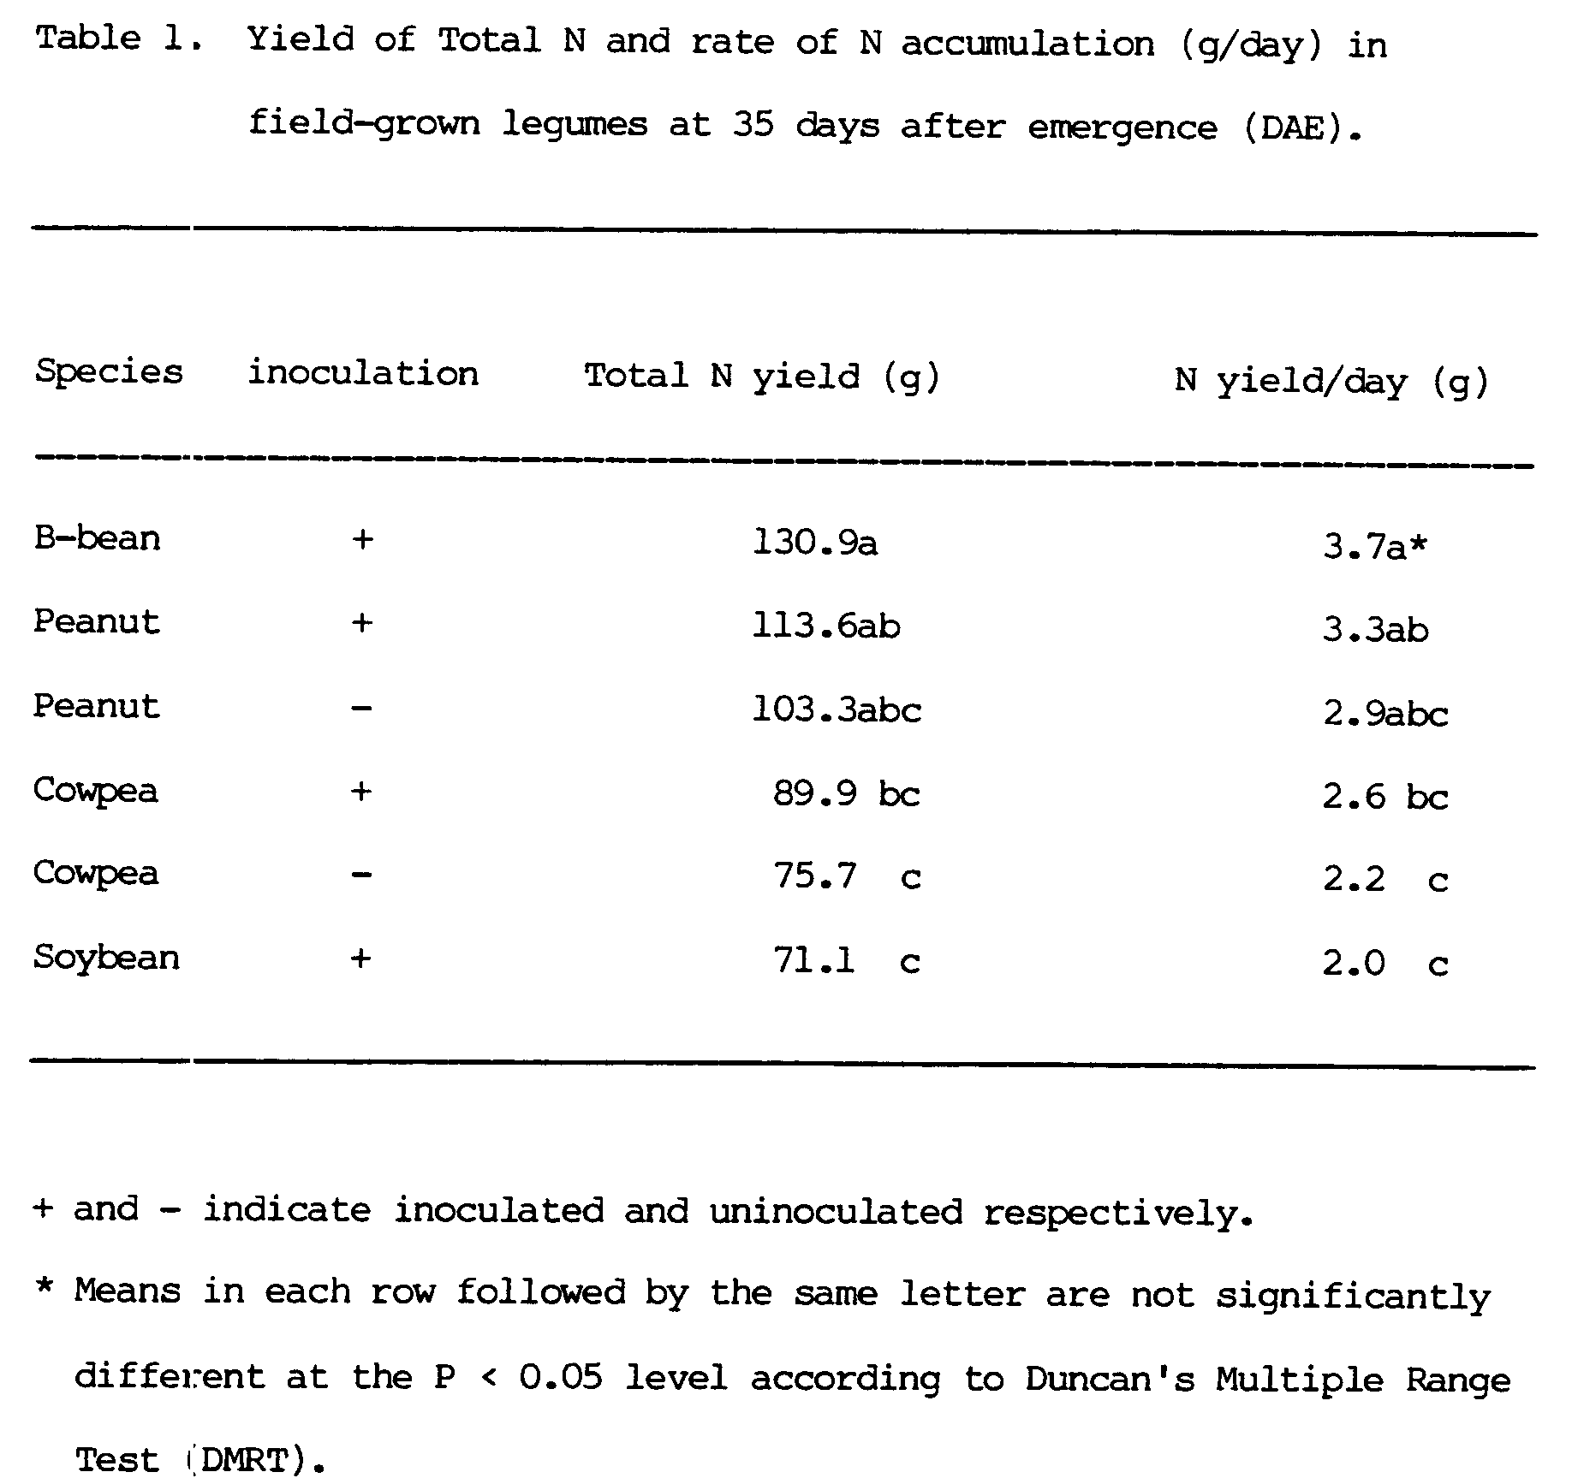
differences in N uptake profiles.
3.2.3.2. Atom % ¹⁵N Excess
Analysis of variance for the atom % ¹⁵N excess in reference crops indicated that there were no significant differences between the reference crops at 30, 60, and 80 DAE. The coefficient of variation for the atom % ¹⁵N excess in soybean, bushbean, and corn was 75.8 % at 30 DAE and 83.7% at 60 DAE. At 80 DAE, the C.V for the atom % ¹⁵N excess in soybean and corn was 90.4%. The high C.V for the atom % ¹⁵N excess in reference crops was probably due to non-uniform application of ¹⁵N solution, soil heterogenity, or the number of plants per sample. The number of plants sampled depended on the number of plants Fer linear meter. Soybean for instance, had more plants per meter than corn. However, at 30 DAE, the linear dilution of the isotope ratios for soybean and bushbean as opposed to a non-linear dilution for corn was observed in a plot of atom % ¹⁵N excess against time for reference crops (Figure 3). The dilution of the isotope ratios in inoculated soybean and both inoculated and uninoculated peanut were also linear (Fig.4). On the other hand, the dilutions of isotope ratios in both inoculated and uninoculated cowpea were not linear, but more similar to that of soybean than that of corn.
The similarity in N uptake and the pattern in the dilution of the isotope ratios in both uninoculated and inoculated soybean together with inoculated and uninoculated peanut meant that these crops were sampling N pools of identical ¹⁵N:¹⁴N ratios. The dilution of the isotope ratios in the fixing peanut and soybean was due to an N source of significantly lower ¹⁵N content, namely the atmosphere, and was attributed to N₂-fixation. The inoculated and uninoculated peanut together with inoculated and uninoculated soybean had similar N uptake patterns and were still growing at 80 DAE (Figure 5). The dilution of the isotope ratios of both inoculated and uninoculated cowpea were also more similar to that of soybean than corn while the total N uptake pattern in inoculated cowpea. Both crops matured at the same time and lost N between 60 and 80 days after emergence.
Since bushbean was mature at 60 DAE, it could not be used as a reference crop
crop for any fixing species other than fixing bushbean. These findings suggest that uninoculated soybean is a good reference crop for estimating N fixation in soybean and peanut. Corn is a good reference crop for estimating N fixation in inoculated cowpea, since the two species had similar N uptake profiles and reached maximum N content at the same time. This is in contrast to the dilution of the isotope ratios.
3.2.3.3. ¹⁵N Dilution Method
The effect of reference crops on N₂-fixation estimates in field-grown legumes using the ¹⁵N isotope dilution method is shown in Table 2. Consistently higher estimates of fixation were obtained with soybean than with corn in all legumes, but the differences in estimates were not significant. It should be borne in mind that where N fixation estimates were negative, a minimum value of 0.1 was included for statistical analysis.
In order to compare bushbean (which matured in 60 days) with other reference crops, it was necessary to compare all reference crops with the mean values for 30 and 60 days after emergence (Table 3). No significant differences were found between the reference crops. However, soybean again gave the highest estimates followed by bushbean while corn gave the lowest estimates for all species. Although there were no significant differences between the reference crops for the N fixation estimates, the low estimates given by corn confirm that N assimilation by corn at 30 and 60 DAE, was different from that of soybean and bushbean.
3.2.3.4 Harvest Date by Reference Crop Interaction by
the ¹⁵N Method
The use of soybean as a reference crop yielded consistently higher estimates of N fixed in inoculated cowpea than the use of corn at all harvest dates (Figure 6). Cowpea appeared to lose N at 80 days after emergence according to the estimates obtained by using soybean as a reference crop, but gained N when corn was used as a reference crop. Since
both inoculated cowpea and corn were physiologically mature at the final harvest and soybean was still accumulating nitrogen, it is possible that estimates made using soybean at 80 days after emergence, may have been due to the differential N uptake by soybean and cowpea. Nevertheless, these estimates suggest that inoculated cowpea lost more than 10 kg N ha⁻¹. In the case of uninoculated cowpea, there was no significant harvest date by reference crop interaction (Figure 7). However, the use of soybean as a reference crop gave consistently higher estimates than the use of corn. Similarly, there was no significant harvest date by reference crop interaction for N₂-fixation estimates in both inoculated and uninoculated peanut and in inoculated soybean (Figures 8, 9, and 10 respectively).
These results indicate that when ¹⁵N isotope dilution method was used to estimate N fixed in field-grown legumes, the use of soybean as a reference crop resulted in non-significant higher estimates than when corn was used as a reference crop.
3.2.3.5. Difference Method
With the difference method, the use of soybean as a reference crop yielded significantly higher estimates of nitrogen fixed in uninoculated cowpea than when corn was used (Table 4). There were no significant differences between the estimates of N fixation in the other species using soybean and corn. When the nitrogen fixation estimates, obtained using all three reference crops, were averaged over the 30 and 60 days and compared (Table 5), the use of soybean as a reference crop gave significantly higher estimates in all species than the use of corn as a reference crop. The use of soybean as a reference crop gave significantly higher estimates in inoculated bushbean than when bushbean was used as a reference crop. Estimates obtained when bushbean was used as a reference crop were significantly different from the estimates obtained when corn was used in most species except inoculated soybean and bushbean. The use of soybean as a reference crop resulted in higher estimates for all species
followed by bushbean, while the use of corn always gave the lowest estimates. These results indicate that at 30 and 60 days after emergence, the estimates obtained when soybean and corn were used as reference crops, were significantly different in all species. Averaged over 30, 60, and 80 days after emergence however, the estimates obtained using soybean and corn as reference crops were significantly different in uninoculated cowpea.
3.2.3.6. Harvest Date by Reference Crop Interaction by the Difference Method
When the difference method was used to estimate the amount of N fixed in various legumes with soybean and corn as reference crops, significant harvest date by reference crop interactions were observed. For inoculated cowpea, there was a significant interaction between harvest date and reference crop (Fig.ll). At 60 DAE, the use of soybean as a reference gave significantly higher estimates in inoculated cowpea than the use of corn. At 30 days after emergence, the use of soybean as a reference crop gave non-significant higher estimates than the use of corn. Estimates obtained using corn as a reference crop at 80 DAE were higher than those with soybean but were not significantly different. In the case of uninoculated cowpea, a highly significant harvest date by reference crop interaction (P < 0.01) was observed (Fig.12). The use of soybean as a reference crop gave significantly higher estimates than the use of corn at 60 days after emergence. The estimates at 30 and 80 DAE using soybean as a reference crop were non-significantly higher than the use of corn. Significant differences between estimates using soybean and corn as reference crops at 60 DAE were attributed to large differences in N uptake between cowpea and corn at 60 days after emergence. There was no significant harvest date by reference crop interaction for inoculated peanut (P < .09). However, the use of soybean as a reference crop gave a significantly higher estimate than the use of corn at 60 DAE. At 80 DAE, the use of corn gave a non-significantly higher estimate than the use of soybean (Fig.13). The
higher estimate obtained with corn as a reference crop at 80 DAE may have been due to the differential N uptake by corn and peanut since peanut was still accumulating N while corn was mature. Moreover, the total N yield by corn at 80 DAE was lower than at 60 DAE, suggesting that corn must have lost N between 60 and 80 DAE. Such a loss of total N by corn explains why N fixation in inoculated peanut may have been overestimated. For uninoculated peanut, the use of soybean as a reference crop gave significantly higher estimates than the use of corn as a reference crop at 60 DAE (Figure 14). At 30 and 80 DAE, the estimates using both soybean and corn as reference crops were not significantly different although the use of soybean as a reference crop gave higher estimate than they use of corn. There was no significant harvest date by reference crop interaction for the N₂-fixation estimates in inoculated soybean (Figure 15). However, the use of soybean as a reference crop gave consistently higher estimates than the use of corn at all dates. At 80 DAE, estimates by corn and soybean were close probably because corn lost N at 80 DAE and the amount of N fixed by inoculated soybean may have been overestimated.
These results indicate that on the average, the N fixation estimates obtained by using soybean as a reference crop were higher than those obtained when bushbean and corn were used as reference crops. The N uptake pattern for the soybean reference crop was similar to that of inoculated peanut, uninoculated peanut, and inoculated soybean. The N uptake pattern of corn was similar to that of the inoculated cowpea, but different from those of other legumes. The harvest elate by reference crop interactions which were observed with the difference method might have been caused by the large differences in N uptake pattern between corn and the legumes. The results are also in agreement with those of Witty (1983), who found that the ideal legume-control combination should have similar rooting patterns and similar N uptake profiles, specifically the same crop growth constant and the same time to half maximum N content.

3.2.4. Nitrogen Fixation Estimates by the ¹⁵N Method
The two parameters evaluated in the N₂-fixation estimates by the ¹⁵N method were harvest date and the reference crops. As displayed in table 6, inoculated cowpea attained maximum N content between 60 and 80 days after emergence (DAE). There were no significant differences between the estimates at 60 and 80 DAE. However, estimates at 30 days were significantly different from estimates at 60 and 80 DAE. Nitrogen fixation estimates in uninoculated cowpea at 60 and 80 DAE were not significantly different. Maximum N content in uninoculated cowpea was at 80 DAE. However, estimates at 30 DAE were significantly different from estimates at 60 and 80 DAE. While N fixation estimates in inoculated cowpea showed a decline at 80 DAE, N fixation estimates in uninoculated cowpea showed an increase. It appears from these results that the N fixation period in inoculated cowpea was shorter than that in uninoculated cowpea probably due to different rhizobia strains. N₂-fixation estimates in inoculated peanut at 80 DAE were significantly different from estimates at 30 and 60 DAE which were also significantly different from each other. Similarly, N fixation estimates in uninoculated peanut at 80 DAE were significantly different from estimates at 60 and 30 DAE which also were significantly different from each other. Although the N fixation estimates in inoculated peanut were not significantly different from the estimates in uninoculated peanut at each harvest date, the estimates in inoculated peanut were higher than those in uninoculated peanut at 60 and 80 DAE. N fixation estimates in inoculated soybean at 80 DAE were significantly different from estimates at 60 and 30 DAE which were also significantly different from each other. In the case of bushbean, N fixation estimates at 30 and 60 DAE were not significantly different.
These results indicate that N fixation estimates in inoculated peanut, uninoculated peanut and inoculated soybean followed the same pattern,
increasing from lowest at 30 DAE to highest at 80 DAE. This is probably because peanut and soybean were long-duration crops compared to bushbean and cowpea which were short-duration crops. Within species however, only cowpea attained maximum nitrogen fixation at different harvest dates probably as a result of inoculation with exotic or native rhizobium strains in the inoculated and uninoculated cowpea, respectively.
3.2.5. N₂-Fixation Estimates by the Difference Method
The difference method has been reported to be less accurate than the ¹⁵N isotope dilution method by many workers (Rennie et al. 1984., Patterson 1982., Vasilas et al. 1984). The N fixation estimates calculated using the difference method were based on the total N balance between a N₂ fixing (F1) and a non-fixing system (nFs). Thus,
N₂-fixed = N yield (Nfl) - N yield (RC). .....(1)
The effect of harvest date on the mean of nitrogen fixation estimates using soybean, bushbean and corn as reference crops in field-grown legumes calculated using the difference method is given in Table 7. N fixation estimates in inoculated cowpea at 30 DAE were significantly different from the estimates at 60 and 80 DAE which were significantly different from each other. Maximum N fixation in inoculated cowpea occurred between 60 and 80 DAE. At 80 DAE, N fixation estimates in inoculated cowpea were less than the estimates at 60 DAE, indicating that inoculated cowpea lost N. N fixation estimates in uninoculated cowpea at 30 DAE were significantly different from estimates at 60 and 80 DAE which were not significantly different from each other. At 80 DAE, N fixation estimates in uninoculated cowpea were still increasing. N fixation estimates at 30 DAE in inoculated and uninoculated peanut were significantly different from estimates at 60 and 80 DAE which were significantly different from each other. N fixation estimates at 80 DAE in both inoculated and uninoculated peanut were still increasing. Similarly, N fixation estimates at 30 DAE in inoculated soybean were significantly different from estimates at 60
and 80 DAE which were significantly different from each other. At 30 and 60 DAE, N fixation estimates in inoculated bushbean were not significantly different.
These results indicate that N fixation estimates in a short-duration crop such as bushbean were not significantly different at 30 and 60 DAE. For an intermediate-duration crop such as cowpea, N fixation estimates at 30 DAE were significantly different from estimates at 60 and 80 DAE which were in turn not significantly different from each other. In long-duration crops such as peanut and soybean, N fixation estimates at 30, 60, and 80 DAE were significantly different from each other.
3.2.6. Comparison of the Methods
The parameter which was used in the evaluation of the two methods was the amount of nitrogen fixed by all the inoculated legumes at three harvest dates using the three reference crops. The relationship of the estimates for the amount of nitrogen fixed at 30 days after emergence using soybean as a reference crop is displayed in figure 16. The correlation between the difference and the ¹⁵N isotope dilution methods was very low (r=0.15). When bushbean was used as a reference crop, the correlation was also low (r=0.38) as displayed in figure 17. When corn was used as a reference crop, the relationship between the estimates by the difference and ¹⁵N methods was negative (r=-17) as is shown in figure 18.
These results indicate that there was no agreement between the two methods using soybean, bushbean, and corn reference crops at 30 DAE. At 60 days after emergence however, the correlation (r=0.82**) for the relationship of the estimates by the difference and the ¹⁵N isotope dilution methods using soybean as a reference crop was high and significant (Figure 19). Similarly, the correlation (r=0.77**) for the relationship between the estimates by the difference and the ¹⁵N isotope dilution methods using bushbean was high and significant (Figure 20). When corn was used as a reference crop, the
correlation (r=0.11) for the relationship between the difference and the ¹⁵N isotope dilution methods was very low (Figure 21). At 80 DAE, the correlations (r=0.91** and r=0.69**) for the relationship between the estimates by the difference and the ¹⁵N isotope dilution methods using soybean and corn, respectively, were high (Figures 22 and 23). At 30 DAE, the coefficients of variation of the estimates by the difference method using soybean, bushbean, and corn were 110.3, 141.7, and 234.9 respectively (Table 8). At 60 DAE, the coefficients of variation (31.7, 43.1, and 111.7) of the estimates by the difference method using soybean, bushbean, and corn as a reference crop respectively were lower than those obtained at 30 DAE. However, the coefficient of variation of the estimates by the difference method using corn as a reference crop at 60 DAE, was still very high compared to those obtained when soybean and bushbean were used as reference crops. At 80 DAE, bushbean was already mature and the coefficients of variation (28.3 and 49.8) of the estimates by the difference method using soybean and corn respectively were lower than those obtained at 60 DAE. The lowest coefficient of variation (28.3) of the estimates by the difference method was obtained when soybean was used as a reference crop at 80 DAE. This explains why the best agreement (r=0.91**) between the estimates by the difference and the ¹⁵N isotope dilution methods was obtained at 80 DAE using soybean as a reference crop.
These results indicate that agreement between the estimates by the difference and ¹⁵N isotope dilution methods was possible depending on (1) the time of harvest, (2) the type of reference crop used, and (3) the coefficient of variation of the estimates by the difference method. Thus, at 30 DAE, there was no agreement between the estimates by the difference and the ¹⁵N isotope dilution methods. At 60 DAE however, there was agreement between the two methods when soybean and bushbean were used as reference crops, but not when corn was used as a reference crop. At 80 DAE, the best agreement between the estimates by the difference and the ¹⁵N isotope dilution methods was obtained with soybean as the
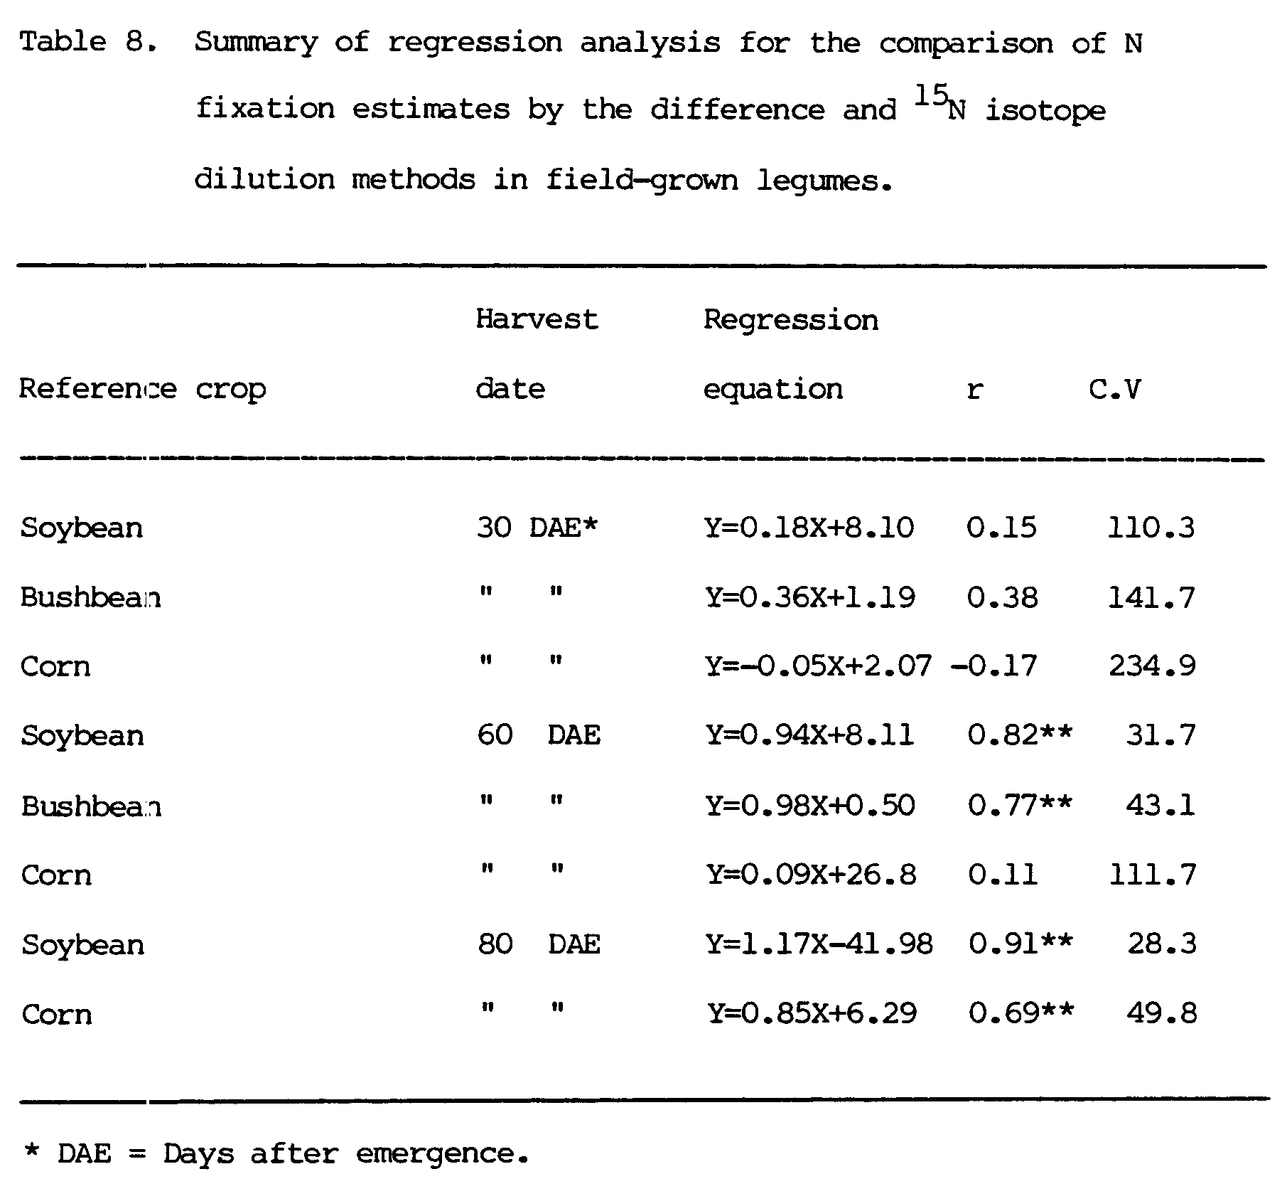
reference crop rather than corn. There was agreement between the estimates by the two methods whenever the coefficients of variation of the estimates by the difference method were less than 100%.
These results are in agreement with those of Talbott et al. (1982). They found close agreement between the ¹⁵N and the difference methods with correlations ranging from r=0.89 to r=0.92 in two sets of experiments. The authors however, found poor agreement between the two methods (r=0.38) when the percent of total nitrogen fixed (%Ndfa) was used as the parameter for the evaluation. Rennie (1984), working with phaseolus cultivars also obtained good agreement between the ¹⁵N and difference methods most of the time when the soil N values were low with only isolated instances of good agreement when soil N values were high. Vasilas et al., (1984) also found excellent agreement between N fixation estimates of the ¹⁵N and the difference methods estimates when soil N conditions permitted proper development of the control plants, but did not depress N₂ fixation.
IV. RESIDUAL NITROGEN
As most of the tropical soils are limited in their ability to sustain continuous crop production due to low nitrogen, and the cost of inorganic fertilizer nitrogen increased, biological nitrogen fixation became the only alternative cheap source of nitrogen for crop production. Information on the residual N contribution to the cropping system by cowpea, peanut, soybean, and bushbean can be used by farmers to improve their crop production practices.
4.1. Materials and Methods
4.1.1. Land Preparation
The experiment was planted approximately one year after the first experiment. Sweet corn (U.H # 9) cv. "Super sweet" was grown on plots that had either been left fallow, grown cowpea, peanut, soybean, and bushbean inoculated or uninoculated, or sweet corn in the previously described experiment. Weeds were kept to a minimum after harvesting the first experiment. A rotovator was used to plow the plots before planting.
4.1.2. Experimental Design
The experiment had been installed in a randomized complete block design with 12 treatments replicated four times in the first experiment. Plots consisted of 4 rows 5 meters long and 65 cm apart.
4.1.3. Treatment Design
The treatments were as described in Experiment I plus three plots which had been left fallow. Urea was applied to all fallow plots at 0, 50, and 100 kg N ha^{-l}; these amendments represent treatments 10, 11, and 12, respectively as shown in figure 24.
4.1.4. Planting and Management
Sweet corn (U.H # 9) cv. "Super sweet" was planted in all plots at 20 cm between hills and 65 cm between rows, giving a plant population of approximately 76,000 plants ha⁻¹. Rows in each plot were run approximately along the rows of the previous experiment with equal width. Furadan was
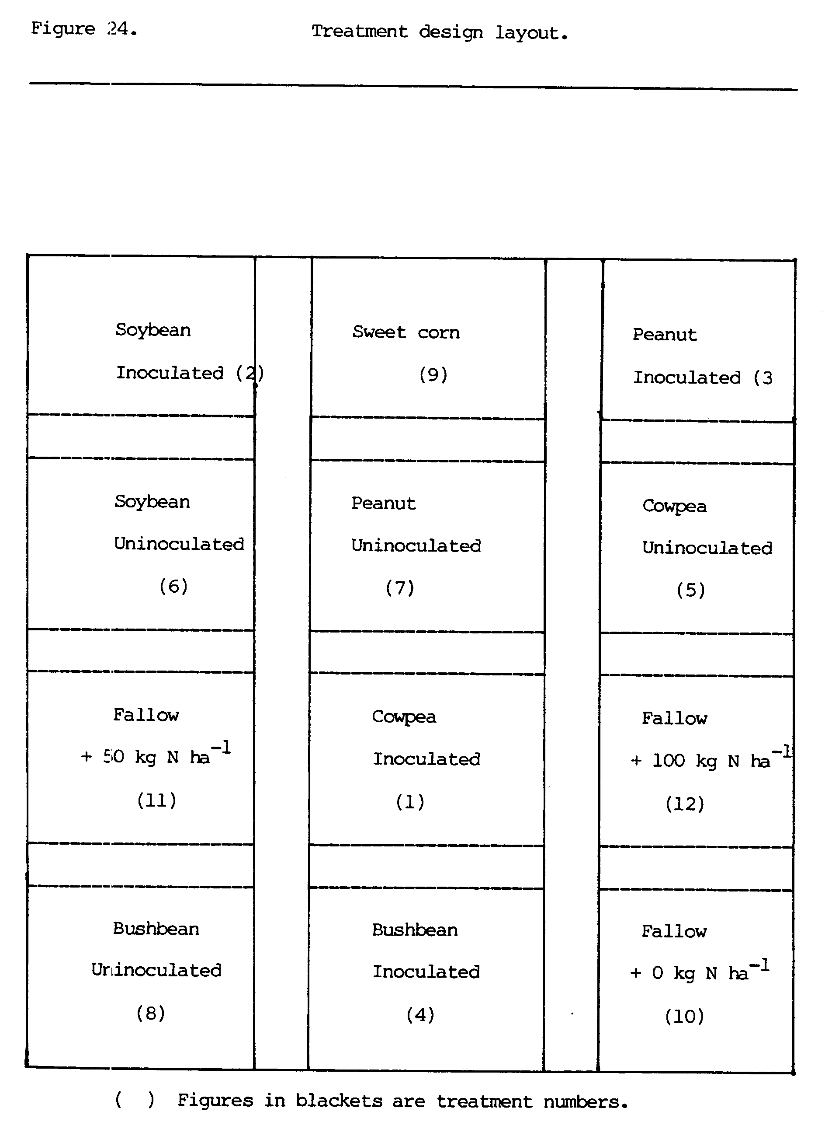
applied at the time of planting at a rate of 3 g/linear meter in furrow rows together with seeds to control stemborers. Drip irrigation lines were laid along the corn rows and plots were irrigated to field capacity every time the top two inches of the soil were dry. Nitrogen in the form of Urea was applied to the fallow plots at 0, 50, and 100 kg N ha⁻¹ in two doses, 1/3 at planting and 2/3 at 40 days after planting.
4.1.5. Harvest and Data Collection
Plant samples for fresh and dry weight were harvested from three meters of the inner rows of each plot 50 days after planting. Subsamples were taken, fresh weight recorded, then subsamples were ovendried at 70⁰, and dry weight recorded. Samples were then ground to pass a 1 mm screen, and subsampled for N analysis. Total shoot N was determined on above-ground plant parts. Nitrogen was determined by the Agricultural Diagnostic Services Center, Agronomy and Soil Science Department, University of Hawaii. Analysis of variance and the Waller test were used to compare treatment means of total N yield.
4.2. Results and Discussion
4.2.1. N Yield
Fallow + 100 kg N ha^{-l} (12) gave the highest N yield and was significantly different from other treatments (Table 11). Inoculated cowpea (1) gave the second highest N yield followed by Fallow + 50 kg N ha⁻¹ (l1) but the two treatments were not significantly different from each other, and were not significantly different from the corn (9), uninoculated soybean (6), inoculated soybean (2), uninoculated cowpea (5), and Fallow + 0 kg N ha -1 (10). They were, however, significantly different from plots which grew inoculated bushbean (4), inoculated peanut (3), uninoculated bushbean (8), and uninoculated peanut (7). Since most of the N contributed by the corn plot (9) came from mineralized soil nitrogen, and these contributed more N than the Fallow + 0 kg 14 ha⁻¹ (10), it appears that mineralization of soil N in plots that previously grew corn was higher than in fallow plots. However, total N yield by corn in Experiment I at 60 days after emergence was 106.4 kq N ha⁻¹ while total N yield of corn at 50 days after emergence was 59.15 kg N ha⁻¹ in Experiment II. It is not clear whether the N that was lost by both corn and inoculated cowpea in Experiment I was responsible for the relatively high residual N contribution to the subsequent crop in Experiment II. These findings emphasize the difficulties involved in quantifying the residual nitrogen from the BNF to the cropping systems.
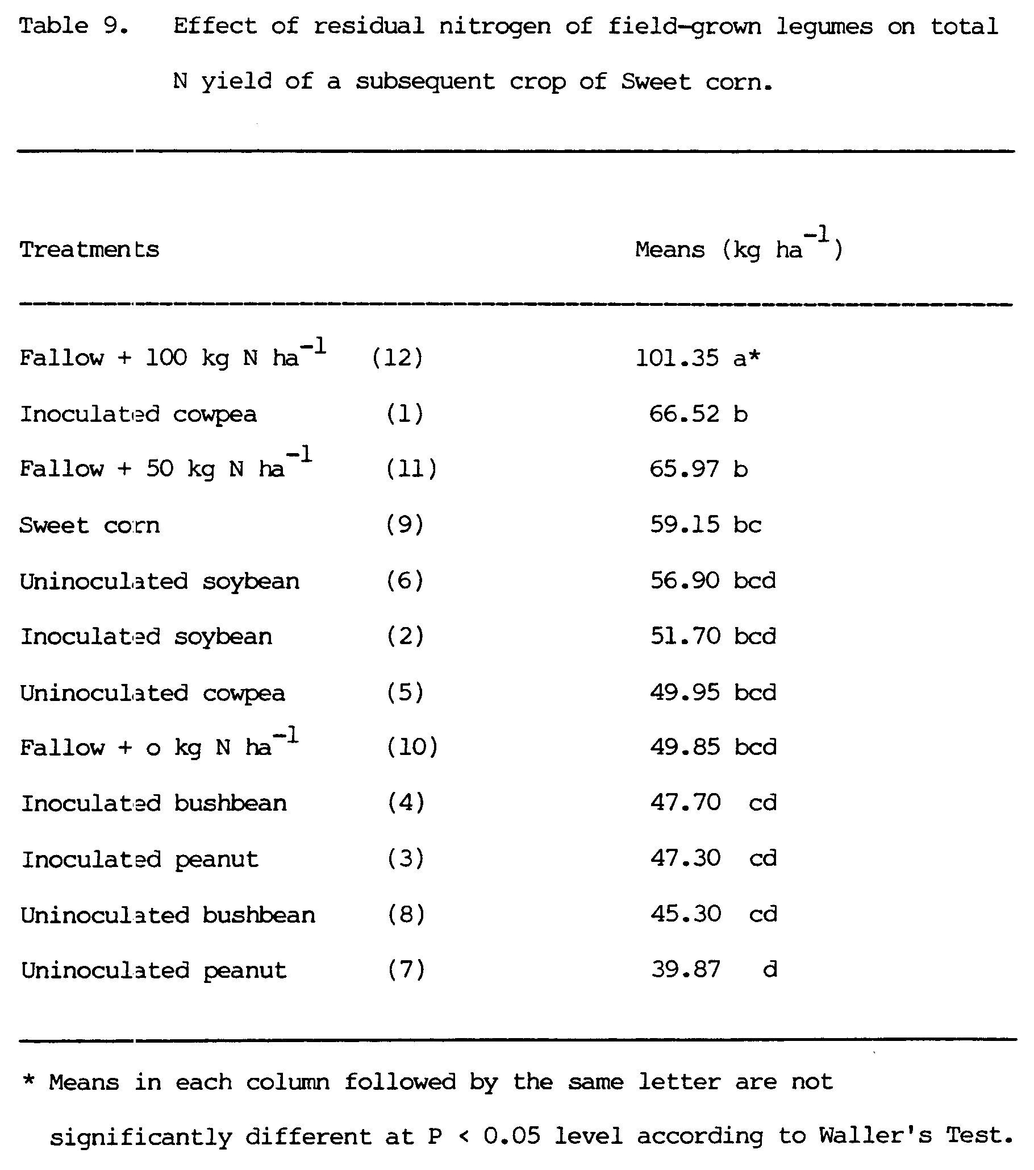
V. CONCLUSIONS
The major conclusions drawn from a field experiment to evaluate the measurement of nitrogen fixation by field-grown legumes are given below.
1. Soil N was sufficiently high that it suppressed the inoculation response of bushbean, an early maturing legume, but not of soybean, a late maturing legume, indicating that soil N level affects the inoculation response by field-grown legumes with varying rhizobial requirements.
2. There was no relationship between nodulation indices and dry matter yield at 35 days after emergence.
3. There was no significant difference in ¹⁵N uptake between the reference crops, soybean, bushbean and corn.
4. There were no significant differences between N fixation estimates using soybean and corn as reference crops with the ¹⁵N isotope dilution method.
5. Nitrogen fixation estimates using soybean as the reference crop were significantly higher than the estimates using corn as the reference crop by the difference method for inoculated cowpea, uninoculated cowpea, and uninoculated peanut. However, N fixation estimates using soybean as a reference crop were not significantly different from the estimates using corn as a reference crop for inoculated peanut and soybean.
6. The use of bushbean as a reference crop was only suitable for inoculated bushbean since it matured before the other species.
7. There was no agreement between the ¹⁵N isotope dilution and the difference methods in the estimates of the amount of N fixed at 30 days after emergence with any of the three reference crops.
8. There was agreement between the estimates by the ¹⁵N and the difference method at 60 days after emergence using soybean and bushbean as reference crops, and at 80 days using soybean and corn as reference crops.
9. The best agreement between the two methods was obtained at 80 DAE using soybean as a reference crop.
10. The coefficient of variation for the N fixation estimates by the difference method was lowest with soybean and highest with corn as reference crops at all three harvest dates.
11. It is difficult to estimate residual N contributed by field-grown legumes without measuring the portion of the soil N that was mineralized during the period between the legume and the subsequent crop.
APPENDICES

Appendix I

Appendix II

Appendix III
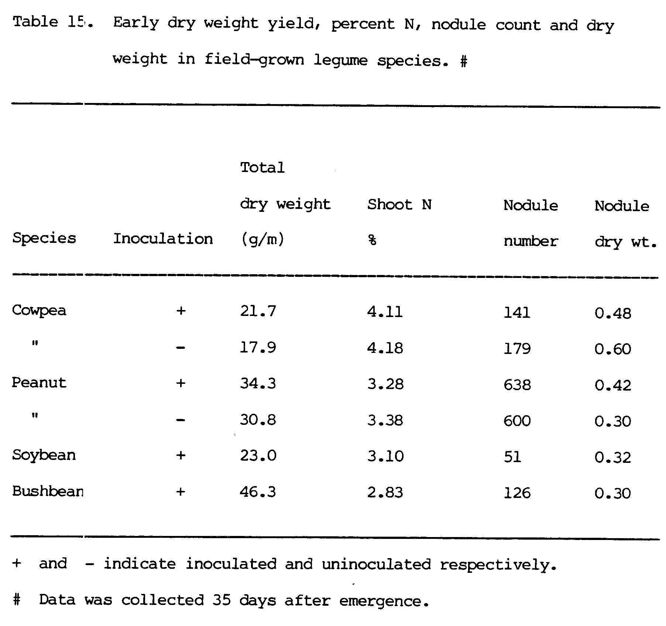
Appendix IV
Appendix V
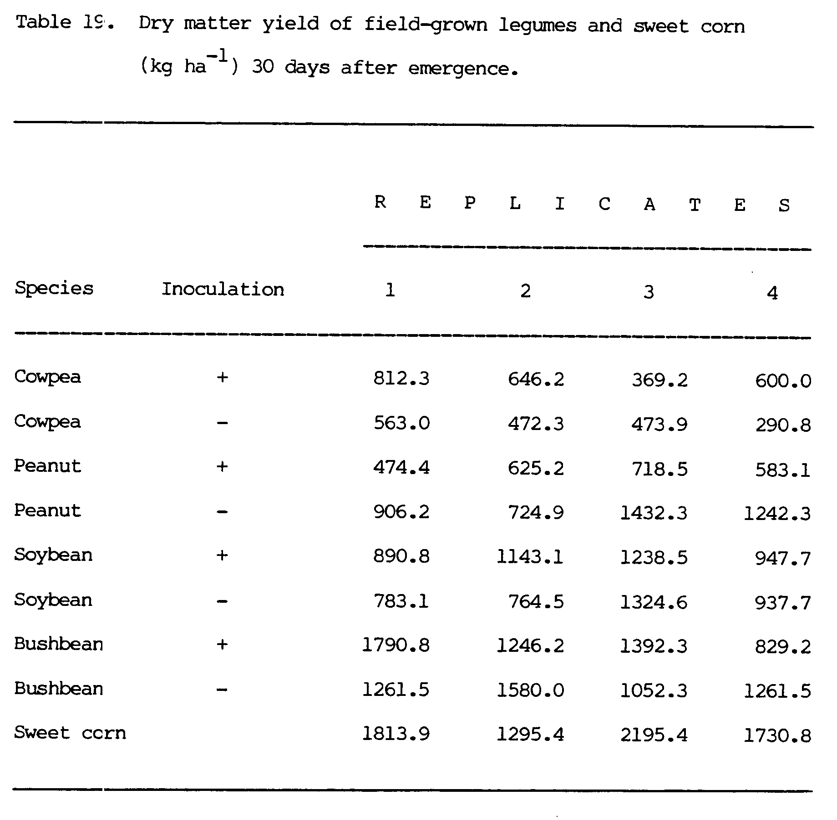
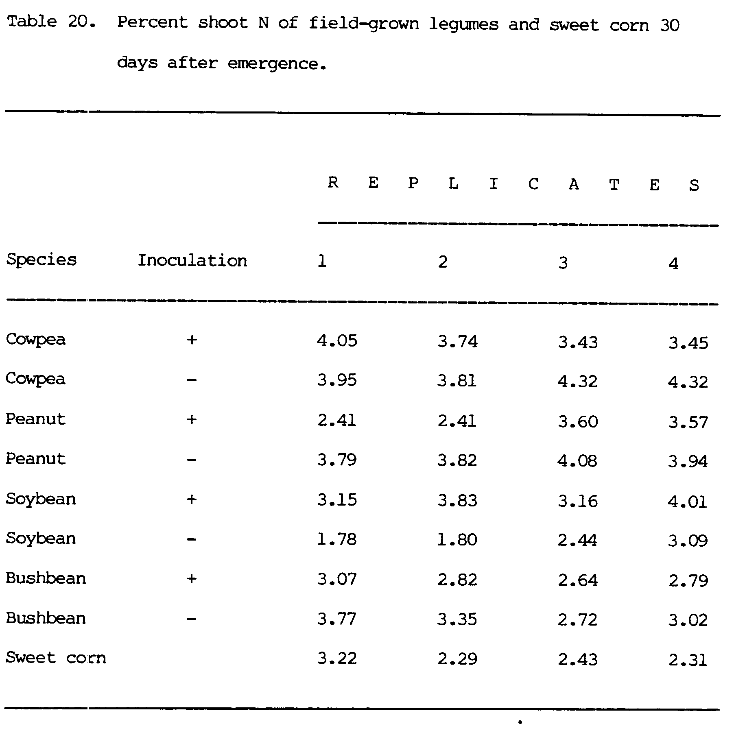
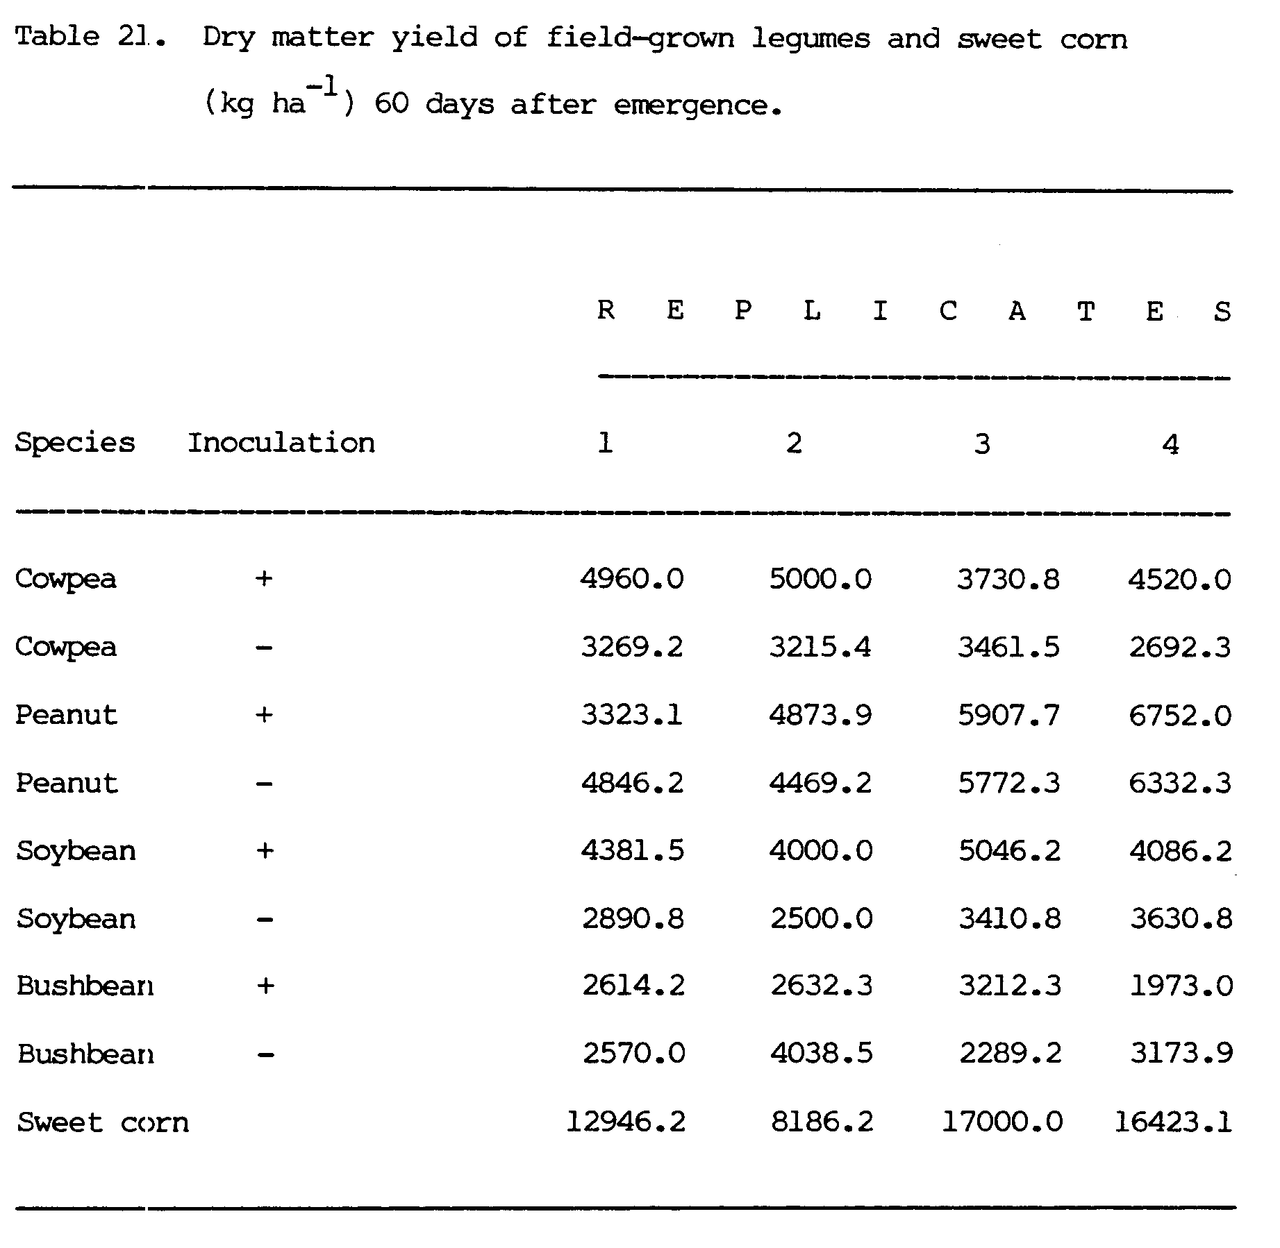
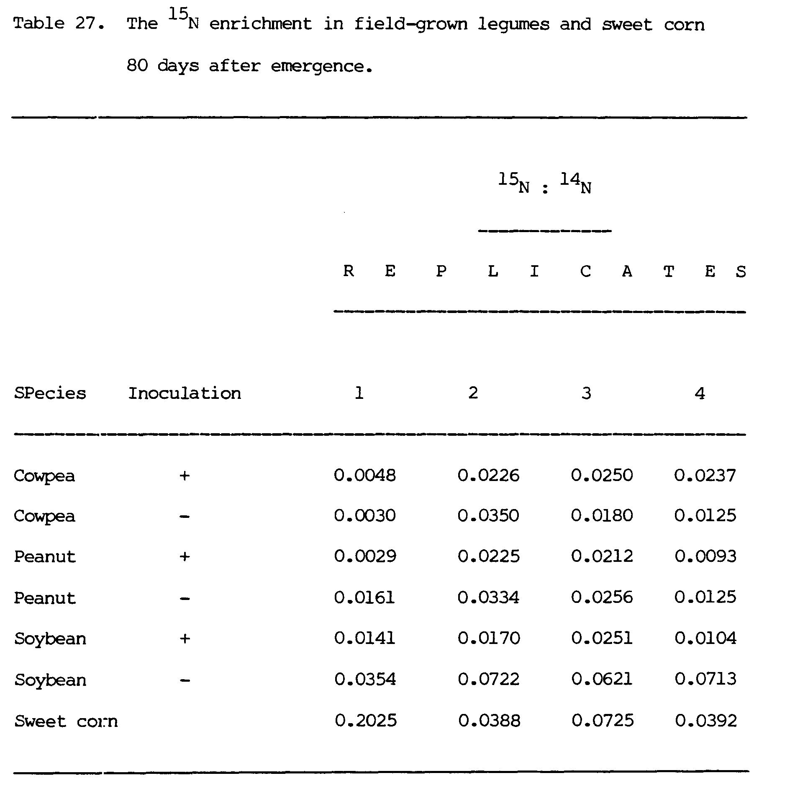
Appendix VI
BIBLIOGRAGHY
Amarger, N., F. Mariotti, J. C. Durr, C. Bouguigno, and B. Lagacherie. 1979. Estimates of N₂-fixation by field-grown soybeans using variations in ¹⁵N natural abundance. Plant and Soil 52:269-280.
Bhangos, M. S. and D. J. Albritton. 1976. Nodulating and non-nodulating Lee soybean isoline response to applied nitrogen. Agron. J. 68:642-645.
Dobereiner, J. and A. B. Campelo. 1977. Importance of legumes and their contribution to tropical agriculture. p. 191-220 In Hardy, R. W. F. and A. H. Gibson (ed.) A treatise on dinitrogen fixation. A Willey-Intescience Publication.
Eaglesham, A. R. J., A. Ayanaba, V. R. Rao, and D. L. Erkew. 1982. Mineral effects on cowpea and soybean crops in Nigerian soil: I. Development, nodulation acetylene reduction and grain yield. Plant and Soil 68:171-178.
_______,1982. Mineral effects on cowpea and soybean crops in Nigerian soil: II. Amounts of N fixed and accrual to the soil. Plant and Soil 68:183-192.
Eaglesham, A. R. J. 1981. Assessing the nitrogen contribution of cowpea (Vigna unguiculata) in monoculture and intercropped. p. 641-646 In Graham, P. H. and S. C. Harris.(ed.) Biological nitrogen fixation technology for tropical agriculture. Papers presented at a workshop held at Ciat, March 9-13, 1981. Cali, Colombia, Centro International de Agricultura Tropical.
Fiedler, R., and G. Proksch. 1972. Emissionspectrometry for routine analysis of ¹⁵N in agriculture. Plant and Soil 36:371-372.
Fried, M., and B. Hans. 1975. An independent measurement of the amount of nitrogen fixed by a legume crop. Plant and Soil 43: 707-711.
Fried, M., and V. Middleboe. 1977. Measurement of amount of nitrogen fixed by a legume crop. Plant and Soil 47:713-715.
Graham, R. A., and A.L. Donawa. 1981. Effect of soil pH and inoculum rate on shoot weight, nitrogenase activity and competitive nodulation of groundnut. Trop. Agric. 58:337-340.
Gibson, A. H., B. L. Dreyfus, and Y. R. Dommergues. 1982. Nitrogen fixation by legumes in the tropics. p. 37-71 In Dommergues, Y. R. and H. G. Diem. (ed.) Microbiology of tropical soils and plant productivity. Martinus Nijhoff/Dr W. Junk Publishers, The Hague.
Hadad, D1. A., T. E. Loynachan, and M. M. Musa. 1982. Inoculation trials on groundnuts (Arachis hypogaea) in Sudan. p. 249-256 In Graham, P. H. and S. C. Harris. (ed.) Biological nitrogen fixation, technology for tropical agriculture. Papers presented at a workshop held at CIAT, March 9-13, 1981. Cali, Colombia, Centro Internacional de Agricultura Tropical.
Harper, J. E., J. C. Nicholas, and R. H. Hageman. 1972. Seasonal and canopy variation in nitrate reductase activity of soybeans varieties. Crop Science 12:382-386.
Kang, B. T., N. Nangju, and A. Ayanaba. 1975. Effects of fertilizer use on cowpea and soybean nodulation and nitrogen fixation in the lowland tropics. p. 204-216 In Ayanaba, A. and P. J. Dart.(ed.) Biological nitrogen fixation in farming systems of the tropics. Based on papers presented at a Symposium held at the International Institute of Tropical Agriculture, Ibadan, Nigeria, in October, 1975.
Larue, T. A. and T. G. Patterson. 1981. How much nitrogen do legumes fix? p.15-38 In Brady, N. C.(ed.) Advances in Agronomy vo1.34 1981 Academic Press. Inc.
Lathwell, D. J. and C. E. Evans. 1952. Nitrogen uptake from solution by soybeans at successive stages of growth. Agron. J. 43:175-179
McAuliffe, C., D. S. Chamblee, H. Uribe-Arango, and W. W. Woodhouse, Jr. 1958. Influence of inorganic nitrogen on nitrogen fixation by legumes as revealed by ¹⁵N. Agron. J. 50:334-337.
Mughoghc, S. K., J. Awai, H. S. Lowendolf, and D. J. Lothwell. 1982. The effects of fertilizer nitrogen and rhizobium inoculation on the yield of cowpeas and subsequent crops of corn. p. 297-301 In Graham, P. H. and S. C. Harris. (ed.) Biological nitrogen fixation technology for tropical agriculture. Papers presented at a workshop held at CIAT, March 9-13, 1981. Cali, Colombia, Certro Internacional de Agricultura Tropical.
Nambiar, P. T. C., P. J. Dart, B. Srinivasa Rao, and H. H. Ravishankar. 1982. Response of groundnut (Arachis hypogaea) to inoculation. p. 241-248 In Graham, P. H. and S. C. Harris. (ed.) Biological nitrogen fixation technology for tropical agriculture. Papers presented at a workshop held at CIAT, March 9-13, 1981. Cali, Colombia, Centro Internacional de Agricultura Tropical.
_______, M. R. Rao, M. S. Reddy, C. Floyd, P. T. Dart, and R. W. Willey. 1982. Nitrogen fixation by groundnut in intercropped and rotational systems. p. 647-652 In Graham, P. H and S. C. Harris. (ed.) Biological nitrogen fixation technology for tropical agriculture. Papers presented at a workshop held at CIAT, March 9-13, 1981. Cali, Colombia, Centro Internacional de Agricultura Tropical.
_______, H. N. Ravishankar, and P. J. Dart. 1983. Effect of rhizobium numbers on nodulation and N₂ fixation in peanut. Expl. Agric. 19:243-256.
Narwal, S. S., D. S. Malik, and R. S. Malik. 1983. Effects of preceeding grain legumes on the requirement of wheat. Exgl. Agric. 19:143-151.
Nelson, A. N., and R. W. Weaver. 1980. Seasonal nitrogen accumulation and fixation by soybeans grown at different densities. Agron. J. 72:613-616.
Norman, M. J. T. 1982. The role of legumes in tropical agriculture. p. 9-26 In Graham, P. H. and S. C. Harris. (ed.) Biological nitrogen fixation technology for tropical agriculture. Papers presented at a Workshop held at CIAT, Colombia, Centro Internacional de Agricultura Tropical.
Okigbo, D. N. 1975. Legumes in farming systems of the humid tropics. p. 60-71 In Ayanaba, A. and P. J. Dart. (ed.) Biological nitrogen fixation in farming systems of the tropics. Papers presented at a Symposium held at the International Institute of Tropical Agriculture, Ibadan, Nigeria, in October, 1975.
Philip, S. T., and E. G. Jaworski. 1975. Patterns of nitrogen utilization in the soybeans. Soil Sci. 73:231-235.
Proksch, G. 1969. Routine analysis of ¹⁵N in plant materials by mass spectrometry. Plant and Soil 31:380-384.
Rachie, K. O. 1975. The nutritional role of grain legumes in the lowland humid tropics. p. 45-59 In Ayanaba, A. and P. J. Dart. (ed.) Biological nitrogen fixation in farming systems of the tropics. Papers presented at a Symposium held at the International Institute of tropical Agriculture, Ibadan, Nigaria, in October, 1975.
Rao, M. M. and K. C. Sharma. 1978. Balance of soil nitrogen and phosphorus as influenced by cropping sequences and fertilizer constraints. Journal of the Indian Society of Soil Science. (1978) 26 (1) 44-48.
Rennie, R. J. 1982. Quantifying dinitrogen (N₂) fixation in soybeans by ¹⁵N isotope dilution: The question of the non-fixing control plant. Can. J. Bot. 60:856-861.
_______. 1984. Comparison of N balance and ¹⁵N isotope dilution to quantify N₂ fixation in field-grown legumes. Agron. J. 76:785-790.
_______, and S. Dubetz. 1984. Multistrain vs. single strain rhizobium japonicum inoculants for early maturing ( 00 and 000 ) soybean cultivars: N₂ fixation quantified by ¹⁵N isotope dilution. Agron. J. 76:498-502.
_______, _______, J. B. Bole, and H. H. Muendel. 1982. Dinitrogen fixation measured by ¹⁵N isotope dilution in two Canadian soybean cultivars. Agron. J. 74:725-730.
_______, and G. A. Kemp. 1983a. N₂ fixation in field beans quantified by ¹⁵N isotope dilution. I. Effect of strains of Rhizobium phaseoli. Agron. J. 75:640-644.
_______, and _______. 1983b. N₂-fixation in field beans quantified by ¹⁵N isotope dilution. II. Effect of cultivars of beans. Agron. J. 75:645-649.
_______, and _______. 1984. ¹⁵N-determined time course for N₂-fixation in two cultivars of field beans. Agron. J. 76:146-154.
Sen, D., and R. W. Weaver. 1981. A comparison of nitrogen fixing ability of peanut, cowpea and siratro plants nodulated by different strains of rhizobia. Plant and Soil 60:317-319.
Talbott, H. J., W. J. Kenworthy, and J. O. Legg. 1982. Field comparison of the ¹⁵N and difference methods of measuring nitrogen fixation. Agron. J. 74: 799-804.
Vasilas, B. L., and G. E. Ham. 1984. Nitrogen fixation in soybeans: An evaluation of measurement techniques. Agron. J. 76:759-764.
Vasios, B. L. 1982. A tracer technique for quantification of symbiotic nitrogen fixation by soybeans. Dissertation abstracts Int. B. 42 (12) 4642.
Vest, G. 1971. Nitrogen increase in a non-nodulating soybean genotype grown with nodulating genotype. Agron. J. 63:356-359.
Vose, P. B., A. P. Ruschel, R. L. Victoria, S. M. T. Saito, and E. Matsui. 1981. ¹⁵N as a tool in biological nitrogen fixation research. p. 575-592 In Graham, P. H. and S. C. Harris. (ed.) Biological nitrogen fixation technology for tropical agriculture. Papers presented at a workshop held at CIAT, March 9-13, 1981. Cali, Colombia, Centro Internacional de Agricultura Tropical.
Witty, J. F. 1983. Estimating N₂-fixation in the field using ¹⁵N-labelled fertilizer: Some problems and solutions. Soil Biol. Biochem.15: 631-639.

